Contact HR Consultant for CV No: 2042208
E-mail: response@gulfjobseekers.com
Website: http://www.gulfjobseeker.com/employer/cvdatabasepaid.php

RESUME
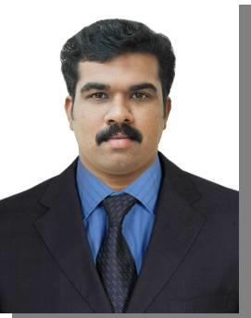

SOORAJ K NAIR

Career Objective

To be a part of dynamic environment and looking at professional growth by way of harmonizing the organizational goals with personal goals.

Academic Qualification

- BCA (Bachelor Of Computer Application)
- .net Application (NIIT)
- Plus Two (XII)
- SSLC ( X )

Working Experience

- Working as the Administrative ,Customer Service and Marketing Executive in SCA speed parcel services LLC, Deira , Dubai. (April 2016 – Till date)

- Worked as Admin executive at Skycom Express LLC, Garhoud, Dubai. (July 2015 - January2016)

- Worked as Data Management Operator and Bill of entry Operator(CMC, DAFZA) in Skycom Express LLC , Garhoud, Dubai. (Sept. 2014 – July 2015)

- Worked as a Document Analyst, Data entry operator , Bill entry operator and office assistant at Vidya Vihar Central School Kakkassery Pavaraty,Thrissur, Kerala.(June – Sept. 2014).
Strengths

- Excellent communication skills.
- Ability to lead and motivate a team.
- Good inter personal skills and ability to work under pressure.

- Ability to negotiate with the customer.
- Ability to canvas the customer.

Responsibilities

- Maintaining the workflow of the company by studying method , implementing cost reduction to gain the companies success.

- Providing the information by answering the questions and request from internal section of the company.

- Maintaining the filling system of the company such as hardcopy and softcopy that are related to the job.

- Preparing the agendas for the future meeting.

- Preparing and modifying documents related to the job such as memos, notifications , letter , drafts and emails

Languages Known
Read | : English and Malayalam
Write | : English and Malayalam
Speak | : English, Hindi, Tamil, Telugu(base) and Malayalam
Understand : English, Hindi, Tamil,Telugu(base) and Malayalam
Passport Details
Date of Issue |  | : 29-03-2010
Date of Expiry |  | : 28-03-2020
Place of Issue |  | : Cochin
License Details
Date of Issue |  | : 22/06/2015
Date of Expiry |  | : 22/06/2025
Place of Issue |  | : Dubai
Personal Profile
Name |  | : Sooraj K Nair
Father’s name |  | : Gopinath M
Mother’s name |  | : Prasanna K
Date of Birth |  | : 11/05/1992
Age |  | : 24
Gender |  | : Male
Marital Status |  | : Single
Religion |  | : Hindu
Nationality |  | : Indian
UAE license no (LMV) |  | : 2140346
Hobbies |  | : Playing cricket, Driving, Listening music and Watching TV

Page 2 of 3

Declaration

I sincerely believe that the above mentioned facts are true to my knowledge and belief.

Place: Your’ truly,
Date: SOORAJ K NAIR

Page 3 of 3

