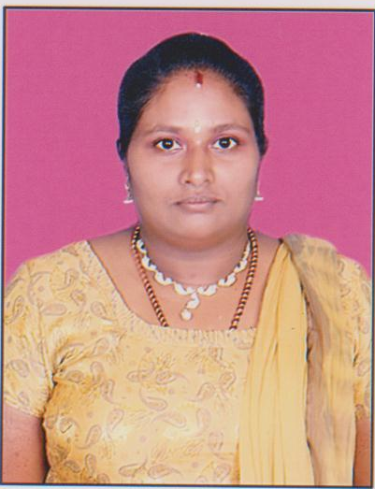

Curriculum Vitae
Kamal
Email Id: kamal.340403@2freemail.com

Objective: To achieve an accounts career wherein I can use my skills to the best of my abilities and be a useful asset to any organization.

Professional Summary: An Enthusiastic professional with hands on experience in Accounting areas, Tally, VAT, CST, BRS, Payroll, statutory areas, (PF, ESI, PT, IT & TDS). Designing CTC & salary Break-up.

Personal Strength: Having good presentable and communication skills, Result oriented, dynamic and energetic enough to travel and willingness to learn new and emerging ideas. Disciplined and managed the work culture and ready to take the work load and execute it successfully to full satisfaction of the clients’ requirement.

Educational Qualification:

B.Com

Additional Qualification:

Software Engineering, D.C.A & Tally 9

Computer Skills: Good working knowledge in word 2007, excel 2007 ,Power point 2007, and advanced excel reports i.e., pivot table, goal seek, auto filters, vlookup, splits & freeze panes which is used prepare to MIS reports, Tally ver.5.4.6 & Payroll Software

Professional Training

1) ACCOUNTS HOUSE

Completed Practical Oriented Work shop covering --

Accounts with Tally 9, P.F. PT and E.S.I, Payroll Processing, Labour Laws, VAT & CST, Service Tax, Banking, MIS Reports and Advanced, Excel Report,

Central Excise, Income Tax, Tax planning for Employees, TDS on other payments Import Procedure, Interview Tips and Soft skills.

Professional Experience

1) Co. Name : SRI LAKSHMI SRINIVASA AGRO FOODS
Designation : Accounts Incharge
Period : 1st January 2014 to 25th January 2017

2) Co. Name : PVK Infrastructure Pvt Ltd
Designation : Account Officer
Period : 21st December 2011 to 31st December 2013

3) Co. Name : SATRAC ENGG Pvt Ltd, Bangalore
Designation : Senior Account Officer
Period : 27th September 2010 to 4th October 2011

4) Co. Name : Power Build Batteries Pvt. Ltd, Bangalore
Designation : Accounts Executive
Period : 4th August 2007 to 25th September 2010

5) Co. Name : M.S.Ramaiah Medical & Memorial Hospital, Bangalore
Designation : Plastic Surgery Secretary and Accountant
Period : 1st April 2006 to 31st December 2006

6) Co. Name : United Enterprises, Kottayam
Designation : Accountant
Period : 1st February 2001 to 1st January 2004

Job Profile:

- Taking care of complete accounting transactions up to B/S Co- ordination with Auditors and providing all the required document, summary, Xerox copies for the purpose of Audit.

- Complete knowledge of VAT - Procedures, Input Vat Entries & forms.

- Overall incharge in admin related work.

--- Correspondence & follow ups.
--- Taking care of order status, Invoicing dispatches etc.
--- Reconciliation at all levels.
--- Periodical Reports & co- ordination with Sales & purchase depts.
--- Monitoring Complete staff details.
--- General Admin related works.
--- Taking care of joining formalities and Relieving & settlement

4. Bank related Matters - BRS FD’s

- Monitoring payroll and designing CTC with break-up of Gross salary,

- Delivering ‘Pay-slips’ with all statutory deductions & preparing ‘Summary of Pay-slips’ including leave calculations.

- P.T., P.F., E.S.I., - Calculations, remittances, filings - i.e., payment challans, monthly / annual returns & PF transfer / settlement forms.

- Taking Care of employees tax calculation, considering exemption, savings and
investment and deduction TDS in payslips every month and issuing form 16 to the employees after the financial year.

- Taking care of TDS on contract payments, placement consultants,
Manpower consultants etc., TDS rates remittances and issuing form 16A etc,

- Knowledge on contract labour act i.e., appointing Manpower Consultant to

heir Contract employees after verifying PF, ESI registration and collecting
necessary Document every month of PF and ESI payments, Knowledge of
shops and commercial Establishment act, bonus act and gratuity act.

- Knowledge of central excise—rules, procedures cenvat entries etc.

- Responsible for overseeing all facts of clients contact, arranging Inventory,
accounts payables and receivables, billing, employee Supervision.

Projects: “Accounts” (Overall Maintain with clearing statuary clearness)

Achievements: Lean more in Various Heads, Team Leadership and Good Communication skill

Extra Curricular Activities: Singing, Dancing, Cooking, Reading

Personal Details:

Date of Birth : 01/04/1978

Nationality : Indian

Marital Status : Married

Languages Known : English, Malayalam, Tamil and Kannada

I hereby declare that the above-furnished details are true with proven records.

Place: Bangalore
Date : Signature

