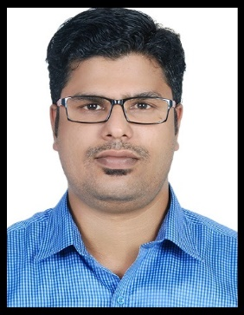
SARATH
Email: sarath.340409@2freemail.com

OBJECTIVE:

To be able to impart my skills and knowledge and to deliver the best quality service of my chosen profession.

EDUCATION:

- BSc Nursing 2005-2010
Rajiv Gandhi University of Health Science, India
- PLUS TWO 2004
- Secondary School 2002

WORK EXPERIENCE:

- Staff Nurse – ICU
Ramdas Clinic & Nursing Home APRIL 2011 – JULY 2015
Perinthalmanna,India

- Staff Nurse- Clinic
SEPT 2015 – Still Working
Dubai

PROCEDURES PERFORMED:
- Firsthand experience in handling cardiac emergencies including Cardio pulmonary resuscitation, defibrillation and administration of emergency drugs

- Maintenance of crash cart, drug trolley, special instruments and all equipment’s.

- Assisted procedures like intubation & extubating, lumbar puncture, paracentesis and thoracentesis, Intercostal drainage etc.

- Skill in interpretation of Arterial blood gas, Electro cardiograph.

- Performed procedures like vital signs checking, sponge bath, iv cannulation, insertion of nasogastric tube, urinary catheterization,suctioning,tracheostomy care, collection of specimens and sending it to laboratory on time.
- Health education patient and family about disease condition, diet and follow-up care.
Proper documentation of records and reports

LICENSES/CERTIFICATIONS:

- DHA –License : DHA-P-0113211
- Registered Nurse : Kerala nursing councilIndiaNo: 20378
- Registered Nurse : Karnataka nursing councilIndiaNo: 034264

SEMINARS/TRAININGS ATTENDED:

- Basic Life Support Provider Course MARCH-2015
(American Heart Association)
Kerala, India
- Advanced Cardiovascular Life Support MAY-2015
(American Heart Association)
Kerala, India

DECLARATION:

I hereby declare that the above written particulars are true to the best of my knowledge and beliefs.

Place: Dubai SARATH

