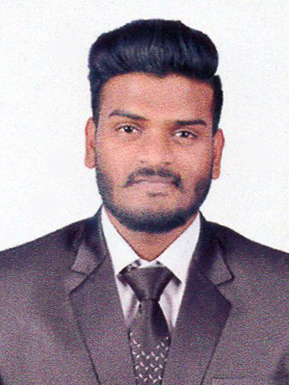

AMEER
Ameer.340432@2freemail.com
C/o- +971505891826

CAREER OBJECTIVE

To get a suitable and challenging position in the Corporate Sector, which would help me build my career and career that provides opportunities for personal and professional development as to contribute to the organization’s effectiveness in order to take the company to the top position where ever I work.

EDUCATIONAL QUALIFICATION
Year of passing | Course | Specialization | Institute | University | Results  (Percentage or CGAP)
2016 | M.B.A  In finance | finance | JSS-CMS  SJCE  MYSORE | AUTONOMOUS( VTU) | 6.55  (CGPA)
2014 | B.B.M | finance | VIDYA VIKAS FIRST GRADE COLLEGE.  MYSORE | MANASA GANGOTHRI | 64%
2011 | PUC | commerce | VIDYA VIKAS PRE UNIVERSITY COLLEGE | STATE BOARD | 67%
2009 | 10TH Standard | - | ST MATTHIAS SCHOOL  MYSORE | KARNATAKA STATE BOARD | 54%

ACCOMPLISHMENTS AND ACHIEVEMENTS

- Was awarded a gold medal for ARTHASHASTRA academy in economics in the year 2011.
- Completed a research project based on the nature of the job and job profile of employees at Indian oil petrol bunk.
- Won first place in the event of finance at MICANVAS fest held at MICA College in the month of march- 2013.
- Won second place at MICA fest held on November 2013 for the event- marketing
- Was the Runner up for the event of finance at ‘Avishkar’ fest conducted by JSS College for women
- Was a part of organizing our college fest ‘Mannovex’ 2014 and 2016 by being an organizer for the event of BEST MANAGER (2014) and TREASURE HUNT (2016).
- Have been the master of ceremony at many events held at college.
- BCA (Basic computer application) advance MS-OFFICE version 2013.

COMPETENCIES:

- Good Communication and Presentation skills.
- Independent and Self-Motivated and hard working.
- Good team player.
- Time management.
- Ability to work under pressure and under deadlines.
- Quick learner.
- Work with positive attitude to contribute the heathy functioning of the organization.

PERSONAL DETAILS

gender male.
marital status unmarried.
date of birth 19 DECEMBER 1993.
nationality indian.
hobbies TRAVELLING, playing cricket, snooker.
linguistic
proficiency English, Hindi, Urdu, kannada.

