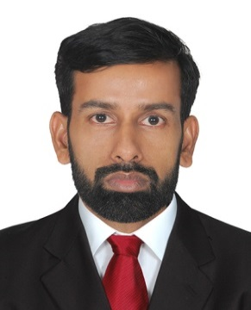
RESUME

RINEESH
Email: rineesh.340440@2freemail.com

Objective

To obtain a challenging accounting position that will permit the use of my current skills to the benefit of the organization and at the same time acquiring knowledge on the road to success.

Career Profile

- Professional accountant with ten years of experience in handling finance, accounting and general business management of various firms
- Proven people management & leadership skills with adequate knowledge in administration duties
- Hold strong logical and crisis handling skills with the aptitude to formulate well planned decisions
- Efficient in multi-tasking and submitting projects within periods

Education

B Com (from University of Calicut)- Kerala (1997-1999)

Computer Proficiency

- Tally Accounting Packages
- COPA(Computer Operator & Programming Assistant(NCVT- GOVT: OF INDIA)
- MS-Office

Employment History

- Accountant at HASSAN AL AMIR GROUP OF COMPANIES-DUBAI- (UAE), May, 2016- Present
- Accountant at NANDILATH G MART(Home Appliance Show Room), Kozhikode, Kerala (Jan, 2014 – Feb, 2016)
- Accountant at INTERNATIONAL STATIONERY - BAHRAIN, ( Sep 2011 to Dec 2013)
- Accountant at KERWINS NAIL MANUFACTURING Co, KERALA - (Feb,2004- Sep,2011)
- Assistant accountant KYNADI (Home Appliance Show Room) KERALA (June ,2001-Dec,2003)

Summary of Experience

- Compile and analyze financial information to prepare financial statements on monthly, quarterly, half yearly and for full financial year.
- Ensure financial records are maintained in compliance with accepted policies and procedures and preparing various analyses of financial status and transaction to report higher management.
- Preparing and maintaining Books of Accounts / Ledgers for sales, purchase etc..
- Responsible for preparing Cash, Bank and Journal Vouchers and their postings.
- Bank Reconciliation and Follow-up of Account Receivables and Payables.
- Vendor management including payment terms /documentation /aging reports.
- Updating of Fixed Assets on monthly basis and Verifying Books of Accounts.
- Preparation of Outstanding Statements and Debtors Reconciliation
- Invoice and document Management and preparation of various analyses.
- Preparation of Credit Note and Debit Note.
- Assisting Office Administration and Handling petty cash

Personal Skills
- Highly dependable, cautious, principled and loyal.
- Excellent analytical skills and Positive outlook.
- Good communication & interpersonal skills with Honesty, integrity and commitment.
- Ability to work under pressure and achieving the task within the stipulated time.
- Capable of handling multiple assignments simultaneously.

Languages Known

English, Hindi, Malayalam, and Tamil

Personal Details
Gender : Male Nationality : Indian
Date of Birth : 21/03/1977 Marital Status : Married
Visa Status : Work Visa
Declaration

I hereby declare that all the information furnished above is true to the best of my knowledge.
(Rineesh)

