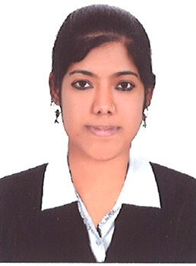
SOUMYA
Dubai, UAE.
Email: soumya.340462@2freemail.com
C/o-Mobile: +971505891826

Career objective:
To succeed in an environment of growth and excellence and earn a job which provides me job satisfaction and self development and help me achieve personal as well as organization goals.

Career profile:
- Detail-oriented, efficient and organized professionals with extensive experience .
- In Tele- Marketing Executive .
- Excellent written and verbal communication skills.
- Highly trustworthy, discreet and ethical.

UAE Work Experience:

Presently working for Country Club Dubai 19 ^{th} sept 2014-present Tele- Marketing and Customer Care Executive.

- Corresponding with customer's Via Email, Tele phone/Fax.
- Adjust sales script to better target the needs and interest of specific individuals.
- Schedule appointment for sales representatives to meet with prospective customer to attend sales presentations.
- Conduct clients or market surveys in order to obtain information about potential customers .
- Answer telephonic calls from potential customers who have been solicited through advertisement.

Experience in India:

First Source Limited.
Location: Coimbatore Tamil Nadu, India.
Job Role : Customer Service (call centre)
April 2012 to May 2013.

- Initiates required action for response to customer service requests for order changes, including the maintenance of order/customer information files and communicates changes to the appropriate personnel/departments.
- Ensure and provides quality service to both internal and external customers.
- Receives inquiries from and /or contacts the organization’s branch/regional offices to resolve a variety of order-related issues.
- Access the company’s internal systems to obtain and extract order information and provide customer service management with the data for inclusion in various scheduled and special reports.
- Performs assigned system maintenance to various electronic order files.
IFB Service
Location : Kerala, India.
Job Role : Accountant cum Cashier
Regular correspondence with customers.
Handling petty cash book –day today cash movements in the office.
Raising requisition for required products.
Maintenance of book of accounts of the firm manually and the corresponding entries are maintained in the system.
Handling regular bank transactions of the firm.
Verifying the supplier’s invoice & preparing cheque against those invoices.
Preparing payroll of the staff and bank reconciliation statement.
Day to day correspondence/ follow up with customers via Telephone ,E-mail & Fax.
Experienced in accepting payments from customers and give changes and receipts.
Education and Specialties:
- Bachelor of Commerce (B.Com)
- Microsoft Word ,Excel, Power Point
- Diploma in Accounting tally and Peach Tree
Languages:
English, Malayalam, Hindi, Tamil
Personal Information:
Date of Birth : 12/05/1991
Gender : Female
Nationality : Indian
Marital Status : Married
Visa Status : Free zone visa
Interest : Travelling, Dancing.
Declaration:
I here by declare that the above written particulars are true to the best of my
knowledge and belief.

In view of the above I request you to be kind enough to give an opportunity to
serve your esteemed organization. I shall be very thankful to you.

Yours faithfully,
SOUMYA

