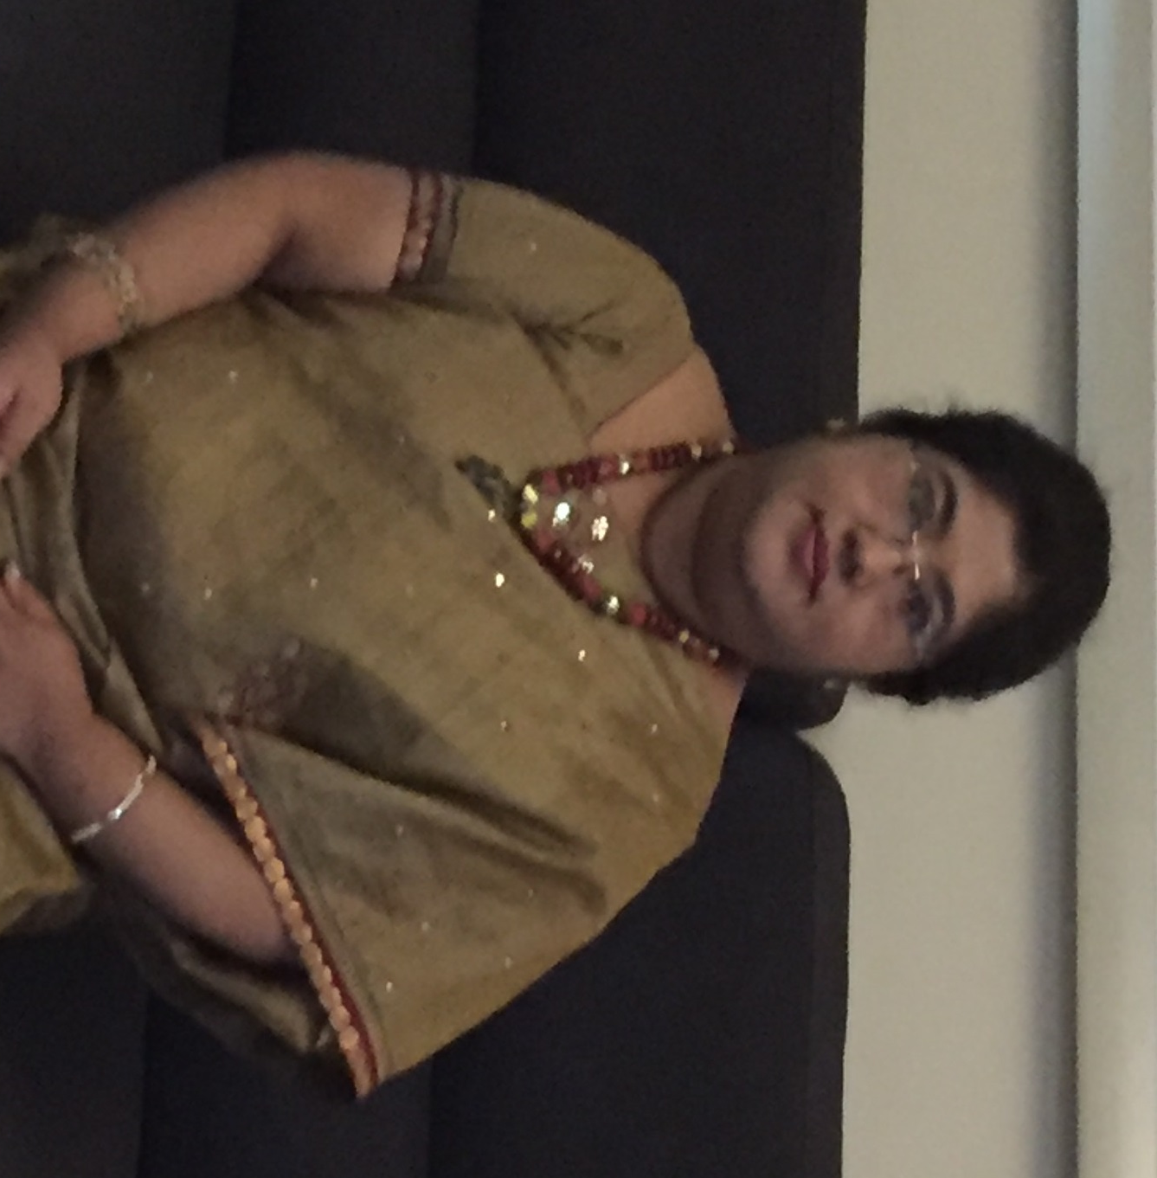
PAMELA

E-mail: Pamela.340466@2freemail.com

C/o-Mobile: +971502360357

Master of Arts in English
Master of Education
Current Country of residence – UAE- Dubai.
Objective:
To train and facilitate teachers in K-12 schools, to mould the tender saplings to achieve their potential. Empower the teachers to develop and realize their creative potential, their goal and vision of life. Maximizing learning experience & opportunities by enthusing the pedagogy with enterprise and entrepreneurial skills along with a more focused curriculum & an enabling environment.
Creation, execution and implementation of a unique Pedagogy and Curriculum adaptation in alignment with the thought processes of the stalwarts in the field of education.
Implementation and execution of Quality Management Systems and processes in teaching and learning
Safe and secure learning environment conducive to the growth and development of the child.
To enable the teachers to facilitate and identify children with special needs and helping out to mainstream these children.
To implement the education strategy developed for each School and provide operational leadership in order to achieve or exceed the School’s business objectives aligned with the Group’s vision, mission and core values.
Career Highlights:
- Overall Twenty three years of experience in teaching and administration in K-12 Schools.
- Eight years in administration.
- Varied Exposure across ICSE,CBSE,IGCSE, International Primary Curriculum, IB and CBSE-i boards.
- Jul 2015 – Till date – Dean,Credence High School,Al Quoz,Dubai,UAE
- Aug 2012- June 2014 –Founder Principal, Sabari Indian School,Dubai,UAE
- 2008-2012 - Principal Litera Valley Zee School- Ichalkaranji .
- 2006-2008- Vice Principal of Gangotri International School- Bangalore.
- 2004-2006-Coordinator and Senior English Teacher in JAIN INTERNATIONAL RESIDENTIAL SCHOOL handling classes IX and X. (C.B.SE and IGCSE)
- 1993-2004:-Over Twelveyears of teaching experience in an I.C.S.E. School (Narbheram Hansraj English School-Jamshedpur) level which was also an I.S.O certified school. Four years as a middle school Co-coordinator and High School co-coordinator.

KEY ACHIEVEMENTS:

- KHDA certified school leader. (Knowledge and Human Development Authority of Dubai)
- Project startup of a new Indian school in Dubai. Successful planning, implementation and execution of the project school in Dubai.
- Academic plan submission and approvals of school licenses from KHDA and the ministry.
- Successful Teachers’ Training-Teaching and Learning Skills, Students attainment and progress-Curriculum design and adaptation.
- Leader in K-12 schools, heading CBSE -grade 10 and 12.
- Creation, Implementation and Execution of quality processes
- Design and development of the curriculum in alignment with the vision and mission of the institution.
- Pedagogy design and development.
- High functioning professional learning community
- Collaboration with colleagues for the implementation of best practices in teaching and learning
- Affiliation of 3 new schools in CBSE and one in CBSE-i
- 100 percent results for the first batch of CBSE students in JIRS-bangalore
- Setting up systems and procedures in alignment with the vision and mission of the new schools..
- 100 percent result for CBSE class 10 –English. Topper procured 98%.
- Best principal award from science olympiad-2012.
- Key stake holder’s satisfaction.

EXPERIENCE:
Educational Leadership and Operational Management:
- Curriculum development and management
- Staff training and development
- Systems oriented approach driving ISO processes and documentation.
- Operations and Logistics Expert Ensuring Smooth Administrative Functioning.
- Ambassador for building a strong brand image for an institution.
- Architect for course curriculum design and development in keeping with Multiple Intelligence.
- Mentor and guide for teachers to instill best values and develop the life skills of children.
- Vision, Mission and Education Strategy
- School Plans and Budgets
- Operational Leadership
- Academic Performance Measurement
- Performance Management.
- School procedures and Processes
- Resource Management
- School Administration
- Providing a safe and healthy environment conducive to learning.
- Quality systems and processes
- Professional development of teachers by developing and implementing policies, programs and plans.
- Plan, direct and design Curriculum. Values woven seamlessly across with the areas of development of a child and the 21st century skills.
- Implementation of Early childhood development and care
- Facilitating activity based learning and pedagogy.

Planning

- The overall responsibility for the successful planning , execution , monitoring , control and closure of Sabari Indian School – Dubai project.
- Successfully implemented of the Vision and mission.
- Lead, managed, recruited and developed the staff and the organization.
- Engaged the Board in planning and leads implementation of policies.

Strategy & Development:

- Evaluated and recommended strategies and policies for cooperative development and planning to the System Board of Directors.
- Developed system wide plans, including collection development, facilities, staffing, and technology.
- Assisted directors and board in the planning processes for further expansions.

Administration & Operations

- Implemented System activities related to long-range plan.
- Prepared and administered the System budget.
- Assured compliance with the state and local laws and regulations.
- Worked closely with State officials in proposed governmental actions that could directly or indirectly affect the operation of the System.
- Design and develop quality manuals as per DSIB indicators.
Basic professional skills- Organizational skills, Team management, Training and facilitation skills, Curriculum development and management, School leadership and management, School administration, Strategic management, Project management, School Budgeting
Human Resource- Hiring, Retention, Training, Mentoring, OrganizationalBehavior, and development, Evaluation
Educational Qualification:
1991 - B.Sc. Calcutta University
2004- M.A. English from IGNOU (Delhi)
2013- M.ED. BHARTIYA SHIKSHA PARISHAD
PURSUING M.Phil.

Professional Development:
- Intel’s Master Trainer
- 100 Hours of training for I.S.O certification
- 200 HoursQuality Circle training of Tata Steel’s Business Excellence in education model.
- 36 Hours of training by CIE to teach IGCSE Curriculum.
- 100 Hours of in-house training by Academy Of Creative Teaching –Bangalore
- 36 Hoursof Principal’s training by Academy of Creative Teaching – Bangalore
- 20 Hours of “Leadership” training by Zee Learn Solutions Limited –Mumbai
- 48 Hours of “Time Management” and “Awakening the leader” in you by Boddhi Corporate Training - Tarun Ahuja.
- 60 Hours of training in INTERNATIONAL PRIMARY CURRICULUM.
- 60Hours of training in “School leadership” by Academic Head – Zee Learn
- Trained in data analysis for Progression Tests- CAT 4-GL Assessments- London.
- “JOURNEY OF EXCELLENCE”- conducted by Yard Stick – Dubai.
Personal Details:
D.O.B: 4TH April, 1969.
Marital Status: Married with a son.
Languages known:English, Hindi& Bengali
Hobbies:Reading, Elocution, Dramatics, Music

References:
Can be furnished upon request

Signature: Pamela

