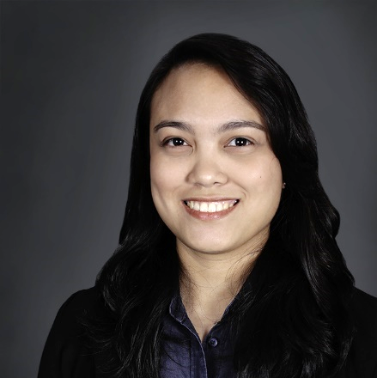

ROMINA
ARCHITECT

As a registered and licensed Filipino architect, I am responsible, efficient and flexible in handling projects. I have strong computer skills and I am willing to learn the new trends in software and technology. After being with top design firms in the country, I have the experience of working on projects ranging from small residential to big-scale commercial projects.

EXPERIENCE

CAD ARCHITECT
ARQUITECTONICA (BFB CONCEPTS INC.) / October 2013 – present / PASIG CITY, PHILIPPINES
Assisted in the production of landscape drawings. Produced architectural drawings from conceptual design through to design development. Provided 3D architectural presentation drawings. Worked on office and big-scale commercial retail projects.
RENDERER / CAD ENCODER
R. VILLAROSA ARCHITECTS / June 2011 - February 2013
PASIG CITY, PHILIPPINES
Built 3D architectural models. Rendered photorealistic perspectives. Prepared presentation drawings. Restored and edited photos for presentations. Assisted in the production of construction drawings. Worked mostly on residential, office and commercial projects.
ARCHITECTURAL INTERN
MC DACANAY ARCHITECTURAL DESIGN OFFICE
April 2009 - May 2009 / CAINTA, PHILIPPINES
Assisted in the production of construction drawings. Inspected construction sites. Prepared presentation drawings.
EDUCATION

UDEMY
CERTIFICATION, REVIT ARCHITECTURE 2016 / January 2017
UNIVERSITY OF SANTO TOMAS
BS ARCHITECTURE / 2006 - 2011
SAMPALOC, MANILA
MICROCADD TECHNOLOGIES
CERTIFICATION, 3D STUDIO MAX 2010 / May 2010
QUEZON CITY
SACRED HEART ACADEMY - PASIG
2002 - 2006
PASIG CITY
SKILLS
- AUTOCAD
- PHOTOSHOP
- REVIT ARCHITECTURE
- SKETCHUP

- V-RAY
- ADOBE LIGHTROOM
- 3D STUDIO MAX

