Ammar

Marketing & Business Development

C/o- +971 50 5891826| Ammar.340531@2freemail.com

Objective
Passionate Business Development professional with more than 3 years of experience in Information Technology looking for challenging responsibility in a reputed organization.

Work

Business Development Executive Jan 2016 – Present
Elitbuzz Technologies DMCC, Dubai

About Company: Advertising Company partners for ZOHO, Etisalat & Google

End to End process of getting business to the Company by offering services like SEO, SEM, Global Messaging, Email Marketing, ZOHO CRM, Cloud-IVR, Short codes, Web Development. Coordinate with resellers, Media Agencies in process of generating volume business. Act as a consultant to clients by providing suitable marketing solutions as per requirement. Worked as an essential part of the team to achieve the team’s target.

Business Development Executive March 2013 - July 2015
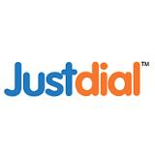
Just Dial Ltd, Hyderabad India

About Company: Top Local Business Directory in India

To Identify and secure new business across Hyderabad city, create new Accounts and Grow a pipeline of new Business. Gather Data of all potential Businesses in an Area, Sell tailored marketing packages as per Industry. Main Client relationship, Implementing Company standards & Create new sales opportunities. Meeting Monthly Quarterly & Annually targets.

Project

Subject – Current Trends in Internet Marketing

An analysis on latest Advertising trends, Market Demand, Career Opportunities Like Mobile Marketing, Online Ads, Social Media, E-Commerce portals, App Marketing.

Education
Bachelor of Business Management (BBM)

Kakatiya University, India - June 2010 – 2012 Aug

Marketing Management

References: Available on Request

Attributes
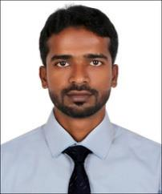
Communication

Team Work

Performance Management

Leadership

Delegation

Motivation & Inspiration

Core Competencies

Prospecting
Presentation Skills

Client Relationships

Negotiation Skills

Creativity Planning
Lead Generation
Market Research
Account Management

Milestones

Head of Cultural Forum

Successfully Organized College

Events.

College Seminar Award

Best Salesman

Awards Won :

Product re-launch

Crack the Case
Business Quiz
Salesman Award

Technical Skills
MS Office Suite : Word, Excel, Power Point

WordPress (Basic)

Personal Dossier
DOB: 21st Nov, 1990
June 2010 - May 2012
Nationality: India

Visa Type: UAE Employment Visa

Languages known: English, Urdu

