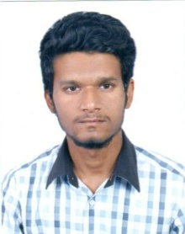
Aamir
C/o- Contact No- +971502360357
Email Id- aamir.340574@2freemail.com

Career Objective
I extremely involved carrying out sales engineering in client service oriented association through stable environment where I would make my supportive participation for the association development.

Academic Qualification
Bachelor Of Engineering From Anna University.

Proficiency
- Languages Of Web Development, Core Java, HTML, J2EE.
- Database Knowledge of MySQL, Jquery, Scripting.
- Skills of Interacting with Adobe Photoshop, PC Troubleshooting, Designing Tools, Document Maintenance, Accounting, Sales Reports, Email Writing, Bugs Fixing.
- Operating Systems Of Windows (Xp,2000,2007/10), Linux, MS DOS.
- MS Office Tools as Word, Excel, PowerPoint.
- 6 Months Experience as a Web Developer from TCI Infotech, Bangalore-India.
- Effective And Well Developed Communication Skills.
- Willingness to learn and accept challenges.
- Self Motivator, Active Listener, Superior Presentation and Interpersonal Skills.
- Agile In Cutting Edge OF Technology, Sales And Engineering.
- Known Languages can Speak, Read And Write ( English, Urdu, Hindi and Tamil).
- Certification of Software Testing from Bangalore.

Professional Experience
IWAYY TECHNOLOGY SOLUTIONS LTD
Roles And Responsibilities:
As Sales Engineer-

- Participating with the account team on early-stage prospect interactions.
- Hosting additional information gathering sessions with technical members of the buying center.
- Assisting the representative with making a go/no-go decision.
- Demonstrating how a product solves the specific use cases for the customer.
- Create sales or service contracts for products or services.
- Research and identify potential customers for products or services.
- Secure and renew orders and arrange delivery.
- Diagnose problems with installed equipment.

