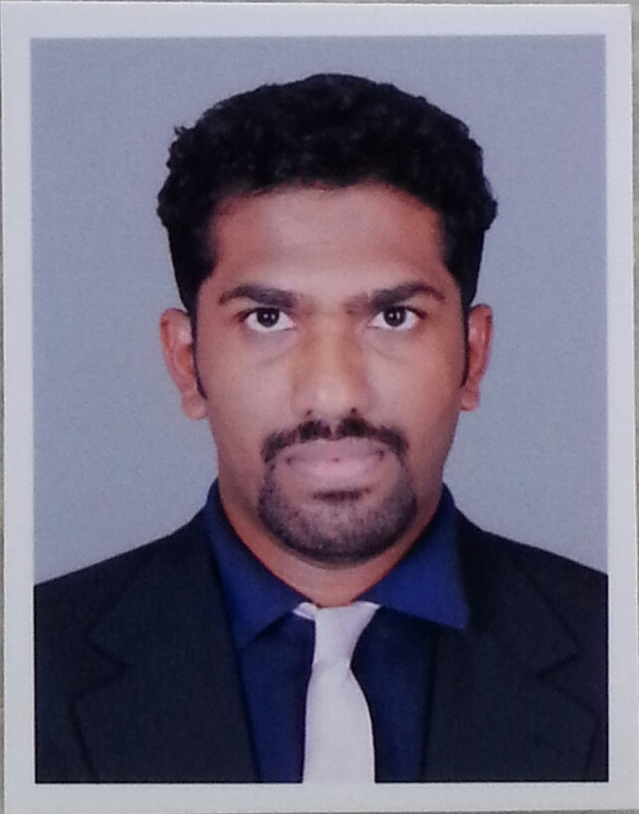HARIKRISHNAN

HARIKRISHNAN.340590@2freemail.com
Personal Details
Gender : Male
Nationality : Indian
Marital Status : Single
Date of Birth : 14 Mar 1988

Looking for a challenging position to lead corporate marketing and internal communications for progressing organization across diverse industries

SUMMARY

Self-directed professional with 3+ years of experience in Marketing, Corporate Communications, Quality Analysis, Guest Services and also includes 1 year of Freelancing experience as a Tutor

Highly skilled in imparting product knowledge to customers over the phone and effectively overcoming objections to sales in a focused manner on increasing sales through efficient marketing efforts

Skilled in persuasive presentation and profitable negotiation with a good exposure to business planning & analysis and assessment to increase revenue growth

Adept at working independently with no direction or as part of a quality assurance team

Immense knowledge of developing and managing the corporate public relation activities

Demonstrated track record of outperforming sales goals, developing new business and strengthening customer relationships with existing client database

Effective leader and mentor who empowers team members to achieve their maximum selling potential

SKILL SET
- Customer Retention | - Tele Marketing | - Escalations Management
- Quality Auditing | - Market Research | - Business Process Improvement
- Employee Training | - Product Knowledge | - Client Relationship Management

EDUCATION
- Bachelor of Engineering in Telecommunications (cleared 1st year- Discontinued later) from Mumbai University Mumbai, India (2010)
- Higher Secondary Education in General Science (Physics, Chemistry and Biology) from Mumbai University, India (2006)

AVAILABILITY
- Planning to relocate immediate

CAREER PATH
Organization | Designation | Duration
Club Mahindra Travel | Telemarketing Executive | Jan 2017 – Till Date
Hexaware Technologies Limited | Senior Executive | Mar 2015 – Dec 2015
Hinduja Global Solutions Pvt. Ltd | Quality Analyst | Sep 2013 – Sep 2014
 | Customer Service Representative | Sep 2012 – Sep 2013

Professional experience
As a Telemarketing Executive
- Maintaining the customer database by entering, verifying, and backing up the data
- Involving in up-selling of holiday packages to new members and upgrading their memberships
- Enhancing the customer relationships by recommending them with new packages/memberships
- Answering telephone calls from potential customers who have been solicited through advertisements

As a Senior Customer Service Executive
Client: Visa Facilitation Services
- Managed customer service help desk responsibilities & associated with the Embassies on the visa application status
- Provided assistance to the customers on overseas flyers with visa requirements and explained about the procedures to apply for various types of visas
- Determined the client problem, clarified the queries and resolved any product or service problems
- Acquired potential customers by answering product and service questions and suggested information about other products and services

As a Quality Analyst
- Involved in auditing the calls/emails & provided feedback & briefed the quality to the concerned & new associates
- Based on client requirements, set audit targets and published monthly quality reports
- Analyzed the top defects in the audit sheet and discussed the defects with the team and the associates
- Improved the quality score by identifying the bottom quartiles and repeat defaulters and highlighted the process gaps found to the clients during audits

For Shoppersstop.com, Hinduja Hospitals:
- Assisted the customers with online shopping for Shoppersstop.com
- Fixed and scheduled appointments with Hinduja Hospitals
- Trained new associates to deal with irate customers
For Hypercity Retail India Limited:
- Audited the data entry work of the Back Office team and provided feedback

As a Customer Service Representative
Client: Vodafone, India
- Managed Front Office Help Desk operations & served as a First point of contact for all the HNI (High Net worth Individuals)
- Involved in upselling of the new offers and resolved any queries with respect to escalations raised for any technical / non-technical issues

Freelance Experience
As a Private Tutor Jan 2016 – Dec 2016
- Taught English for school students and assisted them in dealing with pressure at various stages of life
- Uplifted their career and instilled faith in achieving any hurdles they face in their life
- Underwent international certification for fiber optics telecommunication
- Guided students to create a calendar of deadlines and compiled priority list for assignments
- Encouraged learning beyond the classroom and textbooks

MAJOR ACHIEVEMENTS
- Awarded for the best idea contribution for quality improvement for Shoppersstop.com & Hypercity Retail India limited
- At Hinduja Global Solutions Pvt Ltd
- Bagged “Top Gun Award” consistently for 3 months
- Presented with “Hall of fame” twice for being the top performer
- Received client side - Vodafone appreciations for being consistent performer for 6 months and certified as an Analyst by Vodafone
References are available upon request

