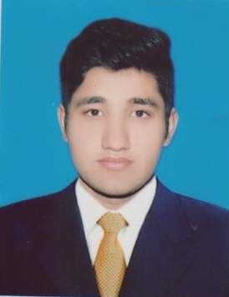
Mohsin
Mohsin.340593@2freemail.com

Career Objectives:-

To seek a challenging position in well-reputed organization where I can apply and update my knowledge and enhance my skills which give me the opportunities to groom in the world of business.

Education:-

Sr. | Level | Year | Division | Board/University
1 | Matric | 2011 | 1st | BISE Gujranwala
2 | D.Com | 2013 | 1st | PBTE Lahore
3 | B.Com | 2015 | 2nd | Punjab University

Computer Skills:-

- 3 Month Diploma in Graphic Designing
- Window 7 & Xp Operating
- Internet & web Browsing
- MS Office
- Composing

Experience:-

- 1 Year experience as an Accountant in Private Firm.
- 1 Year experience as a Salesman in Garment Shop.
- 1 Year experience as an Accountant in HT enterprises (Grw)

Personal Skills:-

- Ability to do work in every kind of situation.
- Hard working and punctual.
- Good in communication & Dealings.

Hobbies:-

- Cricket

