CURRICULUM VITAE

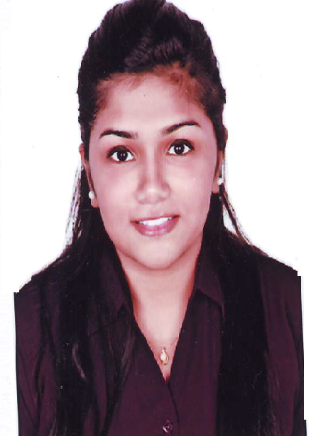
Ms. JENEVY
JENEVY.340818@2freemail.com

Objectives:-

- To work with an organization that offers enhanced opportunity for career growth and development and to gain more knowledge and experience.
- To put my best efforts in my work so as to make the organization grow and thereby grow with the organization.
- To fulfil the requirements of the organization where I am placed and to the best of my potential
- Capacity of adapting to any environment and willingness to learn and improve at every step in life

Assets:-

- Excellent ability to learn new things.
- Willingness to accept challenging job.
- Excellent attitude towards teamwork.

Academic Qualification:-

School / College | Qualification | Year of passing
Sophia’s College | M.Sc. (Analytical chemistry) | 2016
Sikkim Manipal University | MBA (Total Quality Management) | 2017
St. Xavier’s College | T.Y. B.Sc. (Chemistry) | 2014
L.P. Raval College | H.S.C. (Science) | 2011
Holy Cross Convent School | S.S.C. | 2009
 |  | Contd….2/-
Page 2/-
Work Experience

- RAPTAKOS, BRETT & CO. LTD. as Trainee in Quality Control Department

Job Role:-

- Handling GC, HPLC and other analytical instruments
- Approving incoming materials and finished products by confirming specifications
- Conducting visual and measurement tests
- Returning and rejecting unacceptable materials
- Maintaining safe and healthy work environment by following standards and procedures

- KIMATSU HOME APPLIANCES. as Secretary cum Office Assistant
Job Role:-

- Handling the incoming calls, transferring the calls to the different department depending on the request
- Looking after correspondence, self-correspondence & mails.
- Taking care of front office, dispatch of consignments.
- Taking dictations, typing, and filing, inviting quotations, and office secretarial work as when required.
- Keeping record of files.

PERSONAL DETAILS:-

Date of Birth : 5th November, 1993

Languages Known : English /Hindi / Marathi

Visa Status : Visit visa valid till 25th April, 2017

I hereby declare that the above mentioned details are true and as per my knowledge.

