Contact HR Consultant for CV No: 2045142
E-mail: response@gulfjobseekers.com
Website: http://www.gulfjobseeker.com/employer/cvdatabasepaid.php

Usman Ali
Skilled Administrator

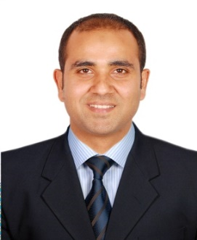

Why Usman Ali?
- Astute, organized & people-oriented professional administrator fully versed in business management & fundamentals. Equipped with extensive knowledge of establishing organizational goals, practices & procedures including directing & overseeing organization’s financial & budgetary activities & sales while identifying glitches to improve operations effectiveness & workforce diversity
- Diligent professional possessing strong commercial acumen with reflective observation to align administrative operations in shaping organizational culture by utilizing cross-cultural intelligence & global mindset. Adept at assessing needs, generating options and implementing solutions in collaboration with management
- Performance-driven individual with ability to motivate team individually & financially to meet corporate objectives through various economic cycles. Expert in prolific communication to handle corporate affairs; absorb information & identify underlying trends with potential & readiness to challenge existing practices & find alternatives
- Well-versed contriver & efficacious team player with ability to communicate to management, over to managers, out to potential employees and down to all levels of current employees including rank-&-file employees. Has exceptional problem-solving and decision making abilities; uncanny ability to transform analytical results into actionable, business-relevant recommendations

CORE STRENGTHS & ENABLING SKILLS
- Business Administration  - Business Communication  - Performance Management | - Operations Management  - Process Development & Implementation  - Customer Relation Management | - Technical Writing  - Interpersonal Skills  - Communication & Presentation Skills

PROFESSIONAL EXPERIENCE
Desert Leisure Swimming Pools (L.L.C) Dubai, UAE
Working as “Administrator”, November 2015 – Present
Responsibilities/Accomplishments:
- Proactively rendering administrative services by handling over 60 projects; preparing submittals for materials & samples within defined time frame & in accordance with log sheet & accelerating undisrupted workflow with increase productivity. Tactfully following up payments & retrieved major amounts accomplishing company targets
- Expertly assisting managing department in implementation of organization’s values, policies, process & procedures by providing Management Advisory Services (MAS) & liaising with contractors, engineering staff, functional & operational management. Arranging meetings, publishing minutes of meeting & training newly hired staff while developing environment of offering information & opinions
Major Achievement:
- Increased overall efficiency by 30% that led to increased customer engagement

PROFESSIONAL QUALIFICATION
- National Textile University, Faisalabad, Pakistan (2010 – 2014)
MBA Finance
- University of the Punjab, Lahore, Pakistan (2008 – 2010)
B. Com

Al-Quoz Industrial Area Dubai
ADDRESS

