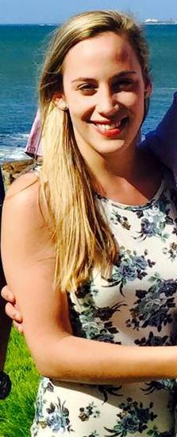
Name: Rineé
C/o- no: +971502360357
Date of Birth: 10/06/1991
Nationality: South African
Residence: Namibia
Email: rinee.340902@2freemail.com
Health: Excellent
Driver’s License: Full license (Code B)
Languages: English: Excellent
Afrikaans: Excellent

- Qualifications:
- 2010 - Matriculated at Windhoek High School, Namibia
- 2014 - Advanced Diploma in Sports Management, Centurion Academy
- 2016 - Post Graduate Certificate in Education, University of South Africa
- 2017 - Teaching English as a Foreign Language (TEFL), LearnTEFL
Subjects:
- Sport Coaching III
- Sport Science III
- Sport Management III
- Sport Marketing
- Fitness Studies III
- Sport Psychology
- Research Methodology
- Kinderkinetics III
- Economics
- Accounting
- Computer literacy
- Communication
- Recreation

- Courses and seminars:
- Metamorpho: one year full time potential and character development course for school leavers ( 2011 ).
- Level 1 Netball Coaching
- Umpiring Netball Level 1
- KFC Mini Cricket
- Level 1 First Aid
- Sport Massage certificate at ETA college, Stellenbosch, South Africa

- Work Experience:

- Part – time
- Sport Massage.
- Sport coaching at Primary schools.
- Kinderkinetics (Orientation programs at Kleine Einstein Primary School and Parrow Primary School) .

- 2015
- Au pair to a private family in Durbanville Cape Town, children aged 4 and 8.

- January 2016 to date
- Assistant Teacher Tsumeb Gimnasium Private School for Gr. 1-3.
- Personal assistant for Primary Principal at Tsumeb Gimnasium Private School.

- Passion:
I enjoy being active and working outdoors, and have a great passion for health and fitness. Working with or spending time with children makes me happy, and I believe teaching is my calling. I consider myself as hardworking, consistent and determined to enable success in everything I pursue. My personality and character allow me to get along with various people and more specifically children, and I there for strive to make a big difference wherever I can.

