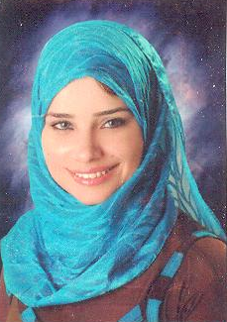

Personal Details:

Name: MAHA
Date of birth: 9 / 4 / 1987
EMAIL: maha.340905@2freemail.com
Marital status: Married
Nationality: Egyptian
Address: Elnahda, Dubai
EDUCATION:

- DHA Eligibility Letter.
- Graduated From The Faculty of Pharmacy, Cairo University.
- Year : May 2009
- Degree: Good+

Objective:

Seeking as Pharmacist in your well reputable Company. Where my ability and skills can be developed and my knowledge can be applied.

COMPUTER SKILLS:

- Good Knowledge of Windows.
- Good Knowledge with Microsoft Office products ( Word – Excel - Power Point )
- Good User to the Internet .

Languages:

- Arabic: Mother language.

- English: Very Good.

Personal Characteristics :

- Quick learning and the ability to work well under pressure and ambition.
- Good Communication Skills.
- Dealing with all kinds of people, and educational backgrounds is a strong point.
- Organized training for employees.
- Very good hard worker.
- Have a good listening skill.
Training Experience:

dasas

- Training in Care Pharmacy Chain for 6 Months.

Working Experience:

dasas

- Worked as Branch Manager in DEGLA Pharmacies
From Jun 2013 to Dec 2016.
- Worked as shift manager in El-kateb Hospital Pharmacy
From Jan 2013 to May 2013.
- Worked as shift manager in Roshdy Pharmacies ( DEGLA NOW )
From Jan 2010 to Oct 2012
- Worked as second pharmacist in Care Chain Pharmacies
From July 2009 to Dec 2009.
- Worked as assistant pharmacist in Care Chain Pharmacies
From July 2008 to May 2009.
- Worked as assistant pharmacist in Sakr Pharmacies
From Jan 2008 to May 2008.
- Worked as assistant pharmacist in El-Saadany Pharmacies
From July 2007 to Dec 2007.
- Worked as assistant pharmacist in Dr. Basem Samir Pharmacy
From Jan 2007 to May 2007.

