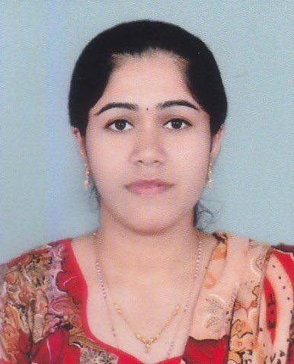

ANNAMMA
Address: Dubai, UAE
C/o-Contact no: +971501685421
E-mail: annamma.340937@2freemail.com
DHA/LS [DHA eligibility letter for Registered Nurse]

CAREER OBJECTIVE
- Provide comprehensive nursing care to standards and practices establish and support to uphold the philosophy and objectives of the unit, nursing department and hospital.
- Seeking a position as a nurse in respected hospital where I can get learning environment along with using my skills for the profitability of the hospital and could serve the patients.

PROFILE SUMMARY
- Registered Nurse
Neonatal Intensive Care Unit (3 years and 9 months)

PROFESSIONAL EXPERIENCE

Medical Trust Hospital Ernakulam (Kerala)
Registered Nurse
August 2013-May 2016
- Modify patient treatment plan as indicated by patients’ responses and conditions.
- Direst or supervise less skilled nursing or healthcare personnel or supervise a particular unit.
- Monitor all aspects of patient care, including diet and physical activity.
- Consult and coordinate with healthcare team members to assess, plan, implement, or evaluate patient care plans.
- Prepare patients for and assist with examinations or treatments.

Fatima Hospital (Lucknow Uttar Pradesh)
Registered Nurse
February 2012 –February 2013
- Skills in Intensive Care Unit (ICU) circulations.
- Monitor record, and report symptoms or changes in patients’ conditions.
- Record patients’ medical information and vital signs.
- Maintain accurate, detailed reports and records.
- Order, interpret, and evaluate diagnostic tests to identify the assess patients’ condition.

DEPARTMENT SKILLS (NICU)
- Monitor vital signs and initiates corrective action whenever the patient displays adverse symptomatology, communicates patients’ condition to care team.
- Provides arterial and intravenous therapy.
- Assists treating physician during examination, treatment and procedures, which can include life saving situation.
- Performs other position related duties as assigned, depending on assignment setting.
CAREER HIGHLIGHTS
- Undergone BLS, ACLS, ECG and Pharmacology program conducted by American Heart Association at IMA Kochi.
- Undergone basic Newborn Care and Resuscitation Program(NRP). Conducted by Navjaat Shishu Suraksha Karyakram at Government Hospital Kochi
- Participated as a medical team member in National Games 2015. Marathon, Cricket League and Football Match.

SKILLS
- Able to adjust quickly and smoothly to changing priorities and conditions.
- Have strong verbal and written communication skills.
- Computer literate (Microsoft offices Word, Excel and PowerPoint)
- Have zest of learning, high stress tolerance and willing to be trained.

EDUCATIONAL ATTAINMENT

TERTIARY

Bachelor of Science in Nursing
Faran College of Nursing
Bangalore, Karnataka (affiliated to Rajeev Gandhi University, Karnataka)
2007 -2011

PROFESSIONAL MAMBERSHIP REGISTRATION
- DHA : Eligibility lettered Registered Nurse
- Karnataka State Nursing Council : Reg No. 45967 (March 2012)
- Kerala State Nursing Council : Reg No. 37504 (July 2013)

PERSONAL DETAILS
Language : English, Hindi, Tamil, Kannada & Malayalam
Date of Birth : May 02, 1990
Marital Status : Single
Religion : Christian Catholic
Gender : Female
Visa Status : Visit Visa

I hereby certify that all the above information’s are true and correct to the best of my knowledge and belief.

ANNAMMA

