Contact HR Consultant for CV No: 2045634
E-mail: response@gulfjobseekers.com
Website: http://www.gulfjobseeker.com/employer/cvdatabasepaid.php

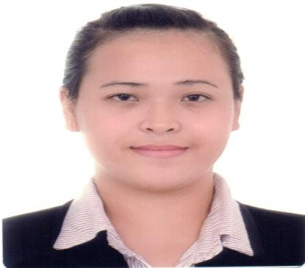MARIE CRIS B. MADRID
Electra St. Abu Dhabi, UAE

AREAS OF EXPERTISE Inventory Management Track and update records Inventory analysis
Physical count Inventory Accuracy Inventory reports

SKILLS

MS Office (WORD, EXCEL & Power
Point)

Task prioritization Time management Communicative Presentable & articulate PERSONAL DETAILS
Nationality: Filipino
Religion: Seventh day Adventist
Birthdate: September 10, 1987
Language: English & Tagalog

Visa Status: Visit
Validity date: March 23, 2017
Availability: Immediate
PERSONAL SUMMARY
A competent candidate with excellent inventory analysis, keen and detail oriented. Have good written, oral and interpersonal communication skills. Organized and willing to accept responsibility in meeting deadlines promptly. Motivated and dedicated to job. Stand on strong work ethic when performing duties and responsibilities.

WORK EXPERIENCE
Reflex Value Concepts Dubai Textile City Dubai, UAE
INVENTORY CONTROLLER January 2014 – February 2016
Duties & Responsibilities:
- Manage both warehouse and retail stores inventory.
- Track and update stocks on sheet and computerized system.
- Performs routine clerical duties, including data entry and processing of Purchase Order/Return, Sales Invoice/Return and Inter branch transfer.
- Verifying periodically the reconciliation between physical quantities in stocks against system quantity by performing stock take.
- Investigate and undertake necessary corrective measures in case of discrepancies.
- Answer telephone calls and assisting warehouse/sales personnel by providing accurate information with stock availability query.

KEY SKILLS AND COMPETENCIES
- Can easily settle in to any role and take over task.
- Flexible and thrive in working in a challenging environment.
- Have knowledge of supplies, equipment and inventory control.
- Able to analyze and solve problems.
- Able to receive and dispatch goods with proper documentation.
- Clerical, word processing and office skills.

ACADEMIC QUALIFICATION
Electronic and Communications Engineering Technology
Mariano Quinto Alarilla Polytechnic College 2004 - 2007
Meycauayan City Bulacan, Philippines

REFERENCES
Available on request

