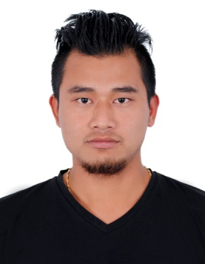

DINESH
Dubai, U.A.E
C/o-Mobil No: +971-503718643
E-mail:dinesh.340950@2freemail.com

aPPLICATION FOR THE POST OF: anysuitable post

objective
Seeking for substantial responsibility where my past and varied experience would be fully utilized in a career opportunity and where making a significant contribution to the success of my employer which will gain me a career advancement opportunity.
competency profile
- Flexible and can easily abject to new environment
- Able to work under pressure
- Self motivated
- High achiever and hard working
work experience

- Worked as a Goods Receiver at Mohebi Logistic LLC, Dubai, UAE, from 2013 to 2015.
- Worked as a Waiter at 3 Star Hotels in Kathmandu, Nepal, for 1 Year.
- Worked as a Cashier at Mahalaxmi Jewelry, SunSari , Nepal , for 10 Months.
key skills

- Well Experience above mentioned field
- Self Confident sincerity Hard Work and Punctuality
- Responsibility in duty
- Honest and dedicated Person
- Good Learning & Listening Abilities
- Committed to providing excellent quality service.
- Learn quickly, and able to work under pressure
EDUCATIONAL QUALIFICATION

- S.L.C Passed from CBSC (Army School Bengugubi , India)
- +2 Passed from Universal Academy , West Bengal , India

computer QUALIFICATION
- 1 year Diploma in Computer Application
- Professional Typing and data Entry Skills
- Excellent in Word Promoting and Power Point Presentation
- Internet E-mail
extra skills
- 3 Months Waiter Trainer Quality training and Employment Center
- Office and Interested Activates
passport details
Date of Issue : 05/11/2014
Date of Expiry : 04/11/2024
Placer of issue : Nepal
Personal Details
Date of Birth : 13/03/1994
Nationality : Nepal
Religion : Hindu
Gender : Male
Marital Status : Single
Language Known : English, Hindi & Nepalese
hobbies

- Designing Traveling Photography , Playing Football , and Adventure
declaration
- I certify that all the details provided above are all correct according to my knowledge and belief.

Dinesh

