Contact HR Consultant for CV No: 2045754
E-mail: response@gulfjobseekers.com
Website: http://www.gulfjobseeker.com/employer/cvdatabasepaid.php

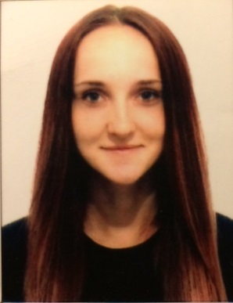
Prodaiko Daria Dmitrievna

Objective | Employment for the position of Receptionist / Hotel manager, Dubai  Application and development of new knowledge and skills in a professional career.
Work schedule  Education  Work experience | Full time  03.2008 - 05.2011 – Technological Lyceum “ORT”, Kiev (“Educational Resources and Technological Training”) – Complete secondary education  09.2011 - 12.2016 – National University of Life and Environmental Sciences of Ukraine, Kiev – Law faculty. Speciality: Jurisprudence. Master of Law.  01.2010 - 08.2014 – Youth leadership club, Kiev– organizer (instructor) of youth programs.  Duties:  - active part and the development of youth scout club;  - carrying out quests in Kiev;  - writing estimates;  - writing, preparation and organization of seminars and thematic events;  - organization and participation in the international exhibition;  - preparation, organization and carrying out of children's summer camps;  - conduct and participate in various educational programs and cultural activities Youth Club.  2011 - 2015 – Head of cultural-mass center at the Law faculty in National University of Life and Environmental Sciences of Ukraine, Kiev.  - active participation and development of Student movements at the Law faculty;  - writing estimates;  - organization and preparation for conferences and events at the Law faculty.  10.2014 - 06.2016 position -financial employee  Duties:  - International financial transfers;  - Purchase / Sale WebMoney;  - Payment of Internet projects;  - Communication with customers;  - Currency exchange.  08.2016 – till today - Foreign company "CCK” (Contact center Kyiv),Kiev - position - Customer Service Manager (Manager Back-office).  Duties:  - Communication with customers;  - Database Management;  - Processing information;  - Record keeping.
Special skills  Personal skills | - Confident user of PC and basic office software (MS Office, Internet, Photoshop).  - Knowledge of others. languages – Russian, Ukrainian, English.  - Experience in conducting and organizing cultural events.  - Have driving license - Category B – 2016  Dependable, initiative, responsible, sociable, punctuale, have creative approach to the solution of tasks, and the ability to articulate my own views.
Courses / Certificates | - ESA - 22303 "Radioactivity and nuclear power" (Wageningen (Netherlands) - Kyiv (Ukraine)  Year of graduation 2016  Participation in the two weeks international course ESA - 22303 "Radioactivity and nuclear power" and obtaining 3 ECTA credits.  - “Informatics and Information Technology Course” (Kyiv)  Year of graduation 2011  During the period from 01.09.2008 to 27.05.2011 has attended and successfully completed the advanced "Informatics and Information Technology Course" at the ORT Resourse Technological Center of the Technological Lyceum, Kiev.

