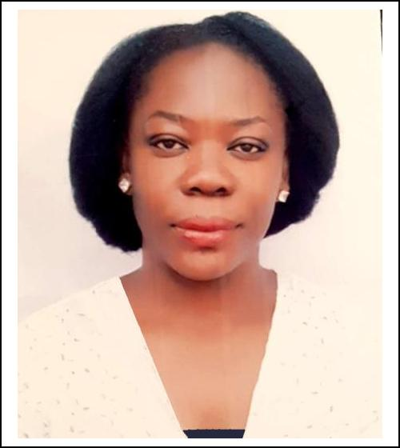

HELEN

HELEN.340966@2freemail.com

With DHA Eligibility Letter

Profile  Personal Data  Work Experience  Education And Qualifications  MEMBERSHIP AND ASSOCIATION  SKILLS  Hobbies  Referees | Trained optometrist with about 5yrs years’ experience in clinic and optical retail practice, with DHA eligibility letter.. She is interested in developing a challenging carrier. Great communication and interpersonal skills with excellent command in English. Including useful experience in practice Management, sales and Business development. currently searching for challenging job opportunities  Sex: Female  Nationality: Nigerian  Date of birth: 01/12/1986  Optometrist/Practice manager March 2013 -Jan 2017  Optical Shop:Dr Hassans Clinics and diagnostic centre No 5 iller crescent,katsina Ala,Maitama Abuja.Nigeria  - Eye examination and refraction  - Instrumentation : lensometry, visual field testing, ocular pressure testing, refraction etc  - Contact lens practice  - Vision aid dispensing  - sales and business development  Corper optometrist July 2011-June 2012  Asokoro General Hospital, Abuja Nigeria  (National youth service corp programme)  Eye examination  Intern Optometrist  Krystal Eye Clinic Jan 2010- July 2011  97 Awolowo road Ikoyi Lagos Nigeria  Doctor of Optometry(OD) 2009  Imo State University, Owerri, Imo State Nigeria  West African School Certificate 2003  Federal Government Girls College Sagamu Ogun State Nigeria  First School Leaving Certificate 1997  Air force Primary School, Ikeja, Lagos  - Member Nigerian Optometric association  - Volunteer Optomtrist: FJC foundation  - Proficiency in instrumentation and clinical diagnosis  - Excellent communication and interpersonal skill  - Organisational and managerial skills  - Discipline  - Ability to adapt  - Focused  - Self-motivated, hardworking and innovative  People networking, reading, and travelling  To be provided on request

