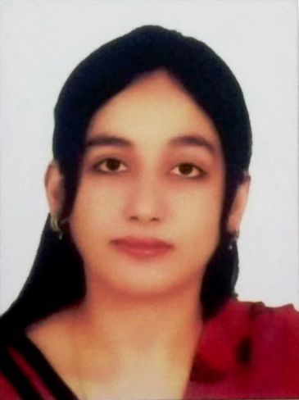
SIDRA
Address: Sharjah, U.A.E.
C/o-Phone no: +971501685421
Email: sidra.340984@2freemail.com

ACADEMICS

Dubai Health Authority (DHA) Exam
General Practitioner (Passed)
January 2017

Aga Khan University Hospital
Post-graduate training, Internal Medicine
(Completed) 2013- 2016

Royal College of Physician and Surgeons
MRCP-I 2016

College of Physicians and Surgeons Pakistan
Intermediate Module
2015
FCPS-1 2012

Dow University of Health Sciences
Bachelor of Medicine and Bachelor of Surgery (MBBS) 2011

St. Joseph’s Govt. College, Karachi
Higher Secondary Certificate (Grade A+)
Pre- Medical 2005

Our Lady of Fatima Girls Sec. School
Secondary School Certificate (Grade A+) 2003

PROFESSIONAL EXPERIENCE

Aga Khan University and Hospital (AKUH), Karachi, Pakistan
Residency Internal Medicine Jan 2013-Dec 2016

Aga Khan University is the only JCIA accredited hospital in Pakistan. It is an 1100 acre campus located in the north of Karachi and encompasses and under-graduate post-graduate programs. It caters to (50,000) hospitalized patients and about six hundred thousand (600,000) patients on outpatient basis annually.
The residency training includes hands on and clinical experience in General Medicine, Emergency Department, Sub-specialties including Cardiology, Pulmonology, Gastroenterology, Nephrology, Oncology, Neurology, Infectious Diseases and Intensive care Units.
Skills: Lumbar punctures, Cannulations, Urinary Catheters, Central Venous Lines, Double Lumen Catheters, Arterial Lines, Bone Marrow Biopsy.

Civil Hospital Karachi
Internship 2011-2012
Department of Internal Medicine (three months)
Department of Cardiology (three months)
Department of Surgery (three months)
Department of Ophthalmology (three months)

During the internship at Civil Hospital Karachi, primary responsibilities included patient clerking, daily rounds, rotations in ER and outpatient clinics and doing cannulations, catheterizations, paracentesis and lumber punctures.

Aga Khan University Hospital
Clinical Electives in the Department of Pulmonology September 2010
Under supervision of Prof. Javaid A. Khan, I rotated on Pulmonology floor and bronchoscopy unit, clerked patients and presented my cases. I was also assigned 3 clinics in a week.

Liaquat National Hospital
Clinical Electives in the Department of Gastroenterology
February 2010
Under supervision of Dr. Pervaiz Ashraf

Civil Hospital Karachi
Clinical Electives in Cardiology
July 2008
Under supervision of Prof. Khalida Soomro

WORKSHOPS AND CONFERENCES

CME on Diabtetes Mellitus for Health Care Professionals, Aga Khan University Hospital 2016
Advanced Cardiac Life support, Aga Khan University Hospital
2015
Workshop on Research Methodology, College of Physicians and Surgeons Pakistan
2013
Workshop on Communication Skills, College of Physicians and Surgeons Pakistan
2013
Workshop on Basic Life support, DUHS June 2011
3rd Annual Symposium 0n Environmental Pollution: A Silent Killer, DUHS February 2007

RESEARCH AND PUBLICATIONS:-
Seroprevelance of Hepatitis B, Hepatitis C and HIV in multi transfused Thalassemia Major patients published in Tropical Doctors Jan 2011.

PERSONAL INFORMATION

Date of Birth: 28-12-1987

Marital status: Married

Visa Status: Visit Visa

Languages
English
Urdu

