Contact HR Consultant for CV No: 2046048
E-mail: response@gulfjobseekers.com
Website: http://www.gulfjobseeker.com/employer/cvdatabasepaid.php

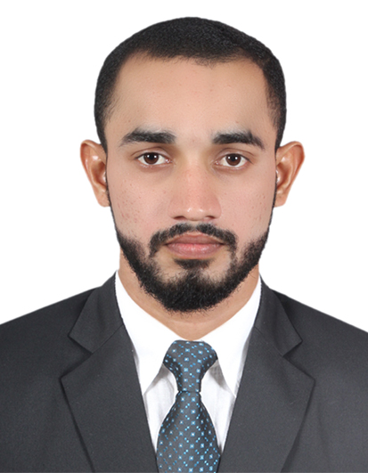

CAREER OBJECTIVES:

To be a value to the organization that provides an opportunity to utilize my knowledge skills effectively and offers good potential for professional growth.
I am writing to apply for a Middle level position with your company in the field of Sales & Marketing and Customer Service. My experience in sales & marketing and the additional skills that I have obtained will make me an asset to your team. Please review my enclosed resume.

POST LOOKING FOR:

Messenger, Office boy, Clerk, Office attendant, Merchandiser Sales Representative

JOB EXPERIENCES: (6 YEARS)

IN UAE (4 YEARS)

Name of the organization | : | Al Bassam Textile Store L.L.C, in Abu Dhabi, UAE.
Duration | : | From August 2014 to Present.
Position | : | Sales
Name of the organization | : | Al Kabhaail Hypermarket Sharjah Rola, UAE.
Duration | : | 2 Years. (2012-2014)
Position | : | Sales
IN INDIA(2 YEARS)
Name of the organization | : | Samsung Cold Drinks in Kochin, India
Duration | : | 2 years
Position | : | Sales men cum Office boy
ON JOB TASK SKILLS
- Welcomes customers by greeting them; offering them assistance.
- Directs customers by escorting them to racks and counters; suggesting items.
- Advises customers by providing information on products.
- Helps customer make selections by building customer confidence; offering suggestions and opinions.
- Documents sale by creating or updating product details.

ACADEMIC QUALIFICATIONS:

1. HIGHER SECONDARY SCHOOL EXAMINATION (12th)
2. SECONDARY SCHOOL LEAVING CERTIFICATE (10th)
3.CERTIFIED GYM INSTRUCTOR OR PHYSICAL TRAINER

COMPUTER SKILLS:

- MS WINDOWS, MS OFFICE
- INTERNET USAGE, EMAILS AND TYPING

LANGUAGES KNOWN:

English, Hindi, Arabic, Malayalam

PERSONNEL DETAILS:

Nationality : Indian
Date of Birth : 06/07/1992
Religion : Islam
Marital Status : Single
Visa Status : Employment Visa

DECLARATION:

I do hereby declare that all statements made in the application are true, complete and correct to best my knowledge.

Date:
Place: Abudhabi,UAE

