Contact HR Consultant for CV No: 341050
E-mail: response@gulfjobseekers.com
Website: http://www.gulfjobseeker.com/employer/cvdatabasepaid.php

Objective: Seeking an opportunity that would best fit my qualifications and develop further my talents and skills to become competitive professional and most especially to contribute growth to the employer through hard work and dedicated performance.

KEY SKILLS, CORE COMPETENCIES AND STRENGTHS

- Good Communication Skill – Good in customer services | Decision making skill | Able to Handle all management Section.

- Energetic | Committed | Win-win attitude | Polite | Presentable | Friendly | Professional at all times.

- Organized | Focused | Math knowledge | Able to work long hours.

PROFESSIONAL EXPERIENCE

ADITHYA MARKETING PVT.
Ponnani, Kerala, India

November 2015 - October 2016.

Duties & Responsibilities

Sells products by establishing contact and developing relationships with prospects; recommending solutions.

Prepares reports by collecting, analyzing, and summarizing information;

Updates managers by consolidating, analyzing, and forwarding daily action summaries; Resolves order and inventory problems by investigating data and history; identifying alternate means for filling orders; notifying managers and customers;

Maintains quality service by establishing and enforcing organization standards; Reviewing your own sales performance, aiming to meet or exceed targets.

VODAFONE CELLULAR LTD.
CV.JUNCTION Ponnani, Malappuram,Kerala , India

January 2014 – September 2015.

Duties & Responsibilities

Outdoor and indoor sales representative selling all Vodafone products; Monitoring the activation process;

Act as a customer service regarding any complain delay in activation;

Present and sell company products and services to current and potential clients; Follow up on new leads and referrals resulting from field activity.

CONCEPT MARKETING PVT.
Trissure, Kerala, India

May 2013 - December 2013.

Duties & Responsibilities

Listening to customer requirements and presenting appropriately to make a sale; Responding to incoming email and phone enquiries;

Gathering market and customer information; Negotiating the terms of an agreement and closing sales;

Acting as a contact between a company and its existing and potential markets; Reviewing your own sales performance, aiming to meet or exceed targets; Attending team meetings and sharing best practice with colleagues.
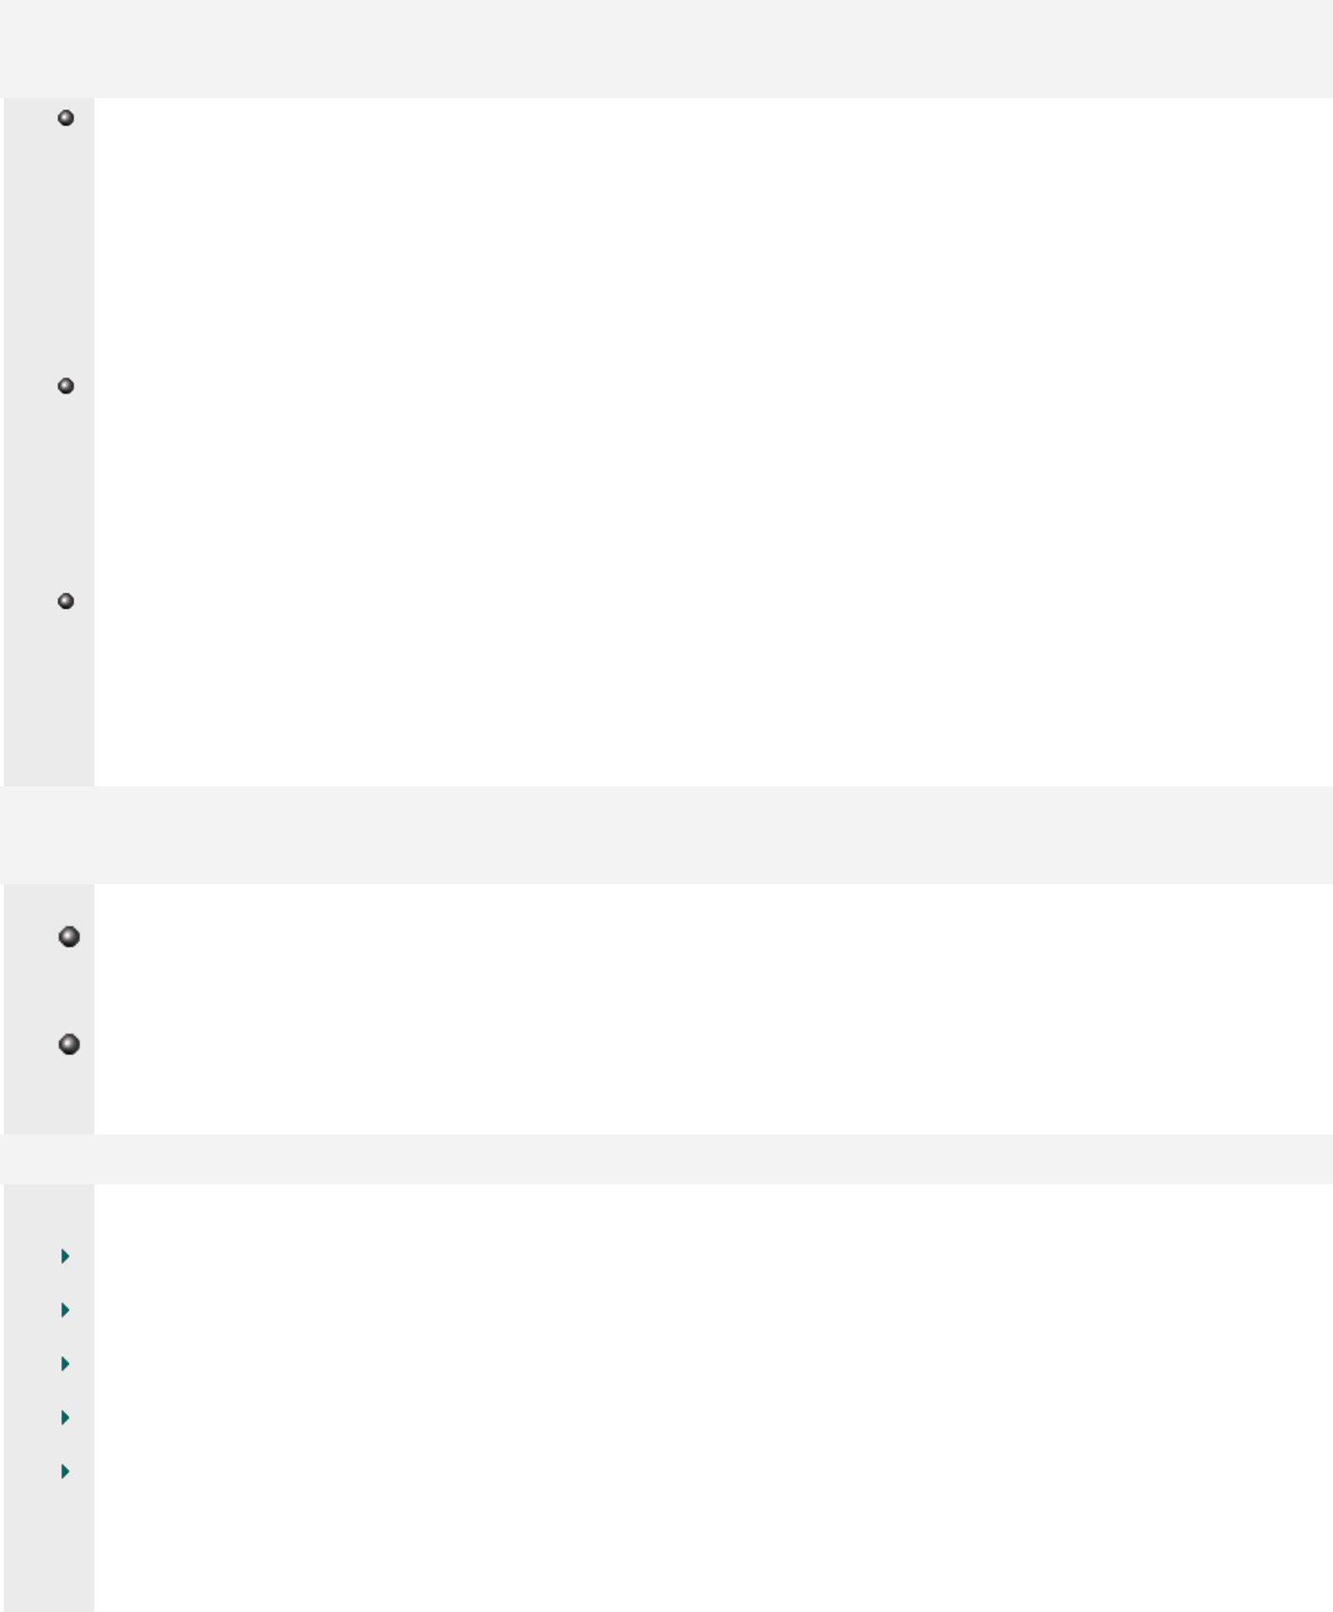

EDUCATION

AIRCRAFT MAINTENANCE ENGINEERING ( AME ) ( 2008 – 2012)

VSM Aerospace Engineering

Approved by Director General of Civil Aviation ( DGCA ) Yelahanka Bangalore,

Higher Secondary Certificate (2008)

Board of Higher Secondary Education.

Ministry of Education, Kerala, India.

Secodary School Leaving Certificate (2006)

Board of Higher Secondary Education.

Ministry of Education, Kerala, India.

AWARDS, ACHIEVEMENTS AND ACTIVITIES

Participated in “National Camp” which was conducted by 16th MADRAS REGEMENT BATTALION. In NCC [ National cadet corps]

Participated in college level cultural and annual programs

LANGUAGES KNOWN

Arabic (Read & Write)

English (All skills)

Hindi (All skills)

Malayalam (Mother tongue)

Tamil (Speak)

PROFICIENCY

- Quick at learning new concepts and technologies and putting them to use.

- Good team player, tactful, self-disciplined and hard working.

- Knowledge of using computer systems

- Good communication and interpersonal skills.

- Experience in classification and analysis of data, information and reports.

- Good handwriting (English), artistic skills, and good intellectual practices.

