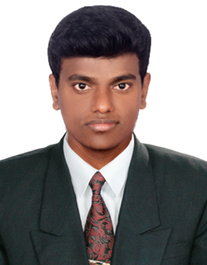
RESUME
HARISH
C/o-Mobile No: 0502360357
Email: harish.341083@2freemail.com
OBJECTIVE

To work in a challenging atmosphere by exhibiting my skills with utmost sincerity and work with commitment in your esteemed organization where I can be part of an environment that encourages learning, hard work & team spirit.

WORK EXPERIENCE

Worked as a System Administrator in Gigatude Software Solutions Pvt. Ltd. from May 2015 to September 2016.
ROLES & RESPONSIBILITIES

DESKTOP SUPPORT SKILLS:

- Installation and updating of Desktop/Server operating system and other software’s.
- Assembling and Maintenance of Desktop machines.
- Troubleshooting of various problems including Software, Hardware and Network issues.
- Installation & Maintenance of Network printers.
- Unlock and reset password for Active Directory user accounts, and finding the route cause for account lockouts.
- Diagnosing and resolving hardware / software /Network issues.
- Performing backups of data and Restore.
- Working with Remote connectivity tools like Remote Desktop, with Amy admin to provide the solutions.
- Providing mailing solution using MS-Outlook, Outlook Express and Windows live mail.
- Updating the antivirus on regular basic and scanning systems.
NETWORK SUPPORT SKILLS:

- LAN and WAN Connectivity.
- Basic Networking, Map drive, Data sharing, IP Configuration, Internet Maintenance
- LAN Cabling (Straight and Cross) Crimping.
- Troubleshooting network connectivity in a LAN/WAN environment.
- Maintenance and Troubleshooting of connectivity problems using Ping, Trace route.
- Adding and Removing Proxy settings for Windows and Android operating systems.
TECHINICAL SKILLS

- WINDOWS: Windows7, 8, 8.1 and 10
- SERVER: Windows 2000 ,2003 and 2008 R2
- Packages: Ms-Office
EDUCATIONAL QUALIFICATION

- B TECH: Bandari Srinivas Institute of Technology in the stream of Computer Science & Engineering completed from Jawaharlal Nehru Technological University, Hyderabad from 2010-2014.
- Intermediate: PRBM Junior College in 2008-2010.
- SSC: ZPHS High School Kalvakota in 2008.
PERSONAL INFORMATION

Gender : Male
Date of Birth : 22-04-1992
Nationality : Indian
Marital Status : Single
Languages : English, Hindi and Telugu

DECLARATION
I hereby declare that above all mentioned are correct to the best of my knowledge.

