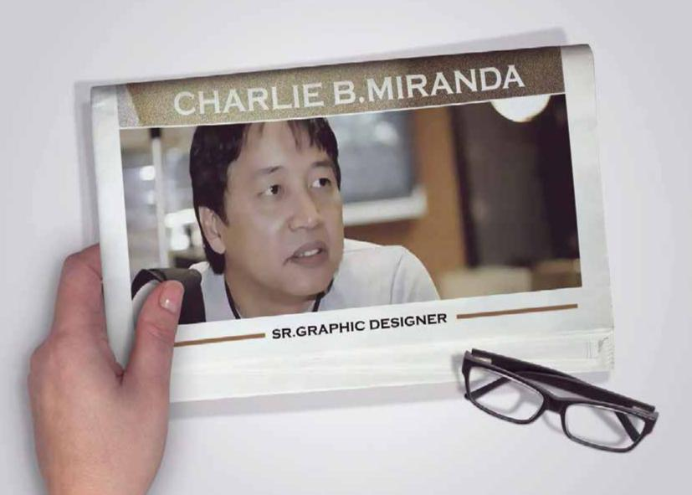

Who i am.....

I am an agreeable person.

I am easy to correct and instruct—I am teachable. I am a loyal employee.

I will complete the job/assignment you give me with excellence.

Charlie B. Miranda

Mob: +971 50 319 8781 • +971 56 900 8134 Email: carrenncore@yahoo.com

Objectives

I am skilled Senior Graphic Designer , passionate yet prag-matic, detail oriented - a strategic thinker. I seek a respon-sible position which will allow me to use my conceptual and visual communication skills to deliver impactful solu-tions.

ethic. My specialty includes: concept and design layout-ing, art direction, branding, editing, photo retouching through production.

My experience includes brand identity, layout design, packaging corporate collaterals, advertising and web design and layouting. My other unique strengths include: Thorough knowledge of current technologies and their relevant applications.

Work Experience

Sr. Graphic Designer

2016- up to present Brandcure Communication, Twofour54 Media City

• Abu Dhabi UAE

Working from a brief with a head creative and copywriter or other members of a creative team, generating ideas to present to the client.

Working on designs for branding, above and below the line, packaging,2D, collaterals and photoshoot in order to

Art Director / Sr. Graphic Designer

2009- October 2015 Futurevision Adv. Co. • Riyadh

Sr. Graphic Designer

2003-2009 •Horizon FCB Adv. Co. • Riyadh

Graphic Designer

2003-2004 • Impact BBDO • Jeddah

Skills

I’m creative. have a thorough understanding of photography, typography and printing.
Have excellent interpersonal and communication skills work well as part of a team, with a range of people
have excellent computer skills in relevant art and design software packages.

Able to work under pressure highly motivated and well organised have a good eye for details.

Able to see other people's point of view and cope with criticism able to work within strict budgets.

Photography is also my passion and Mac user.

ConceptPortfolio&

Design

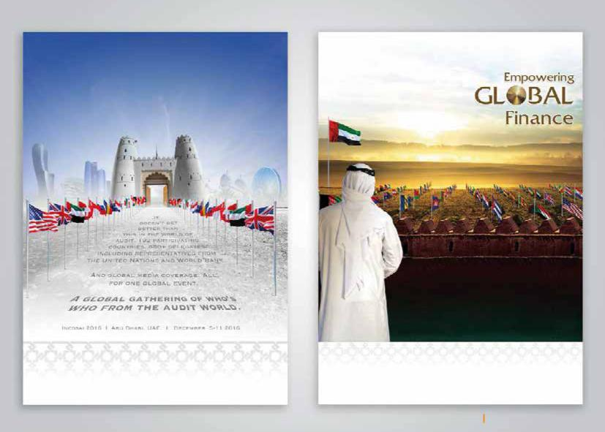

INCOSAI MASTER VISUAL

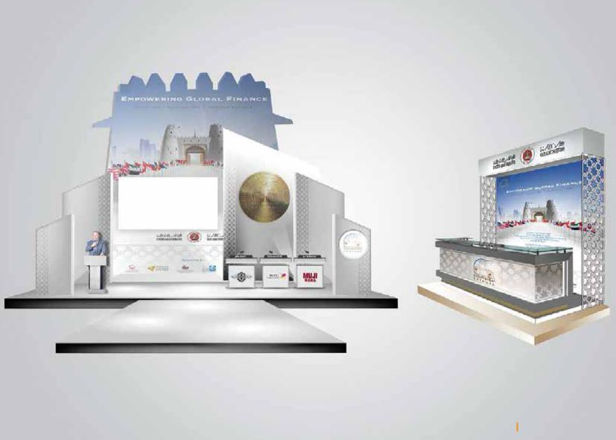

BOOTH AND STAGE

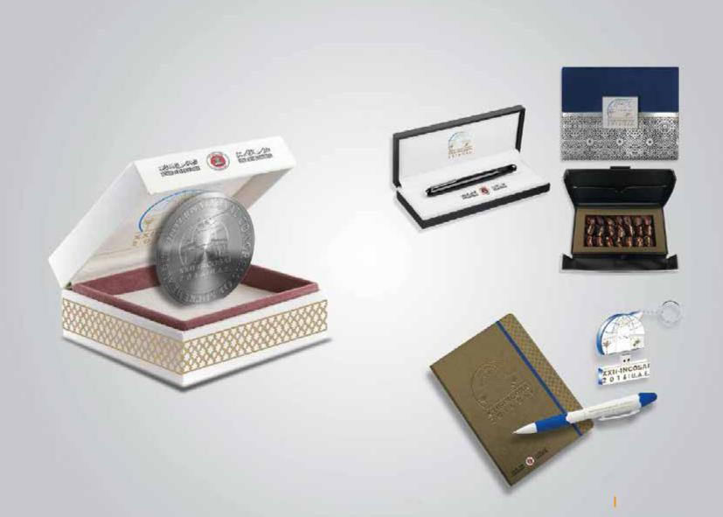

GIVEAWAY ITEMS

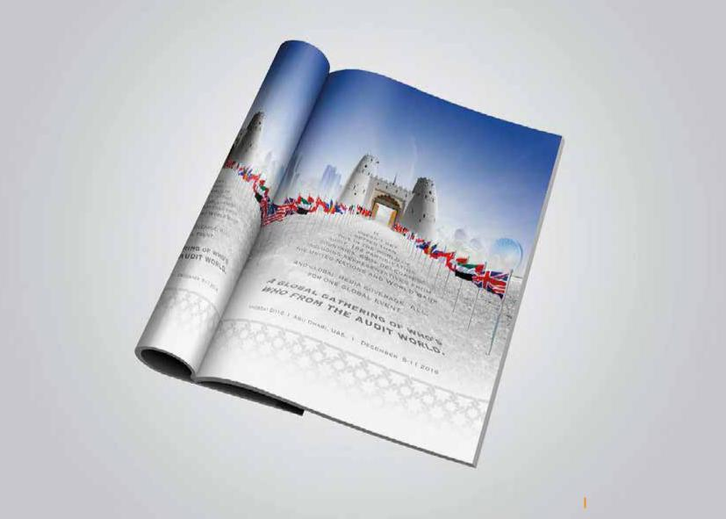

PRESS AD MAGAZINE

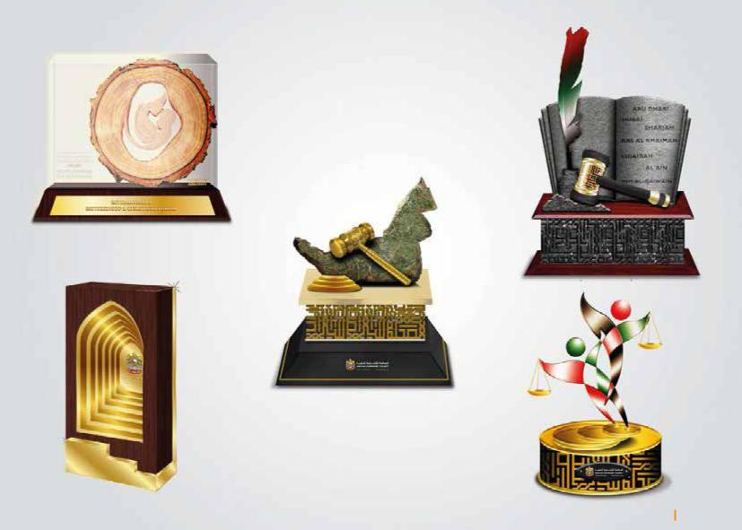

TROPHY

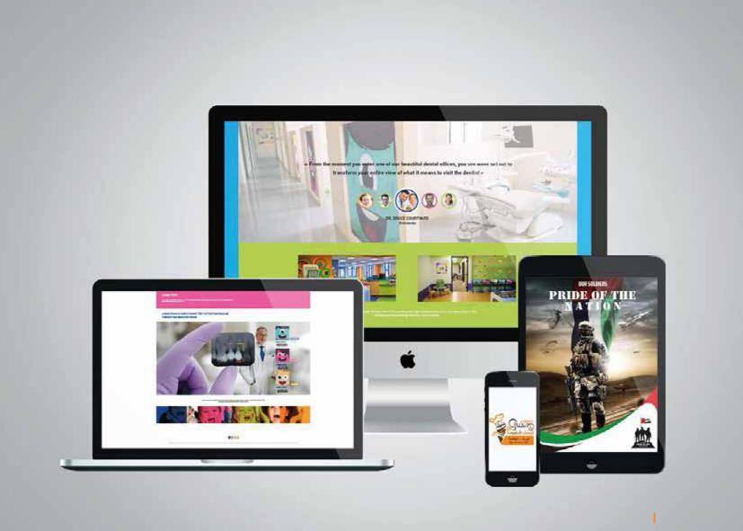

WEB DESIGN

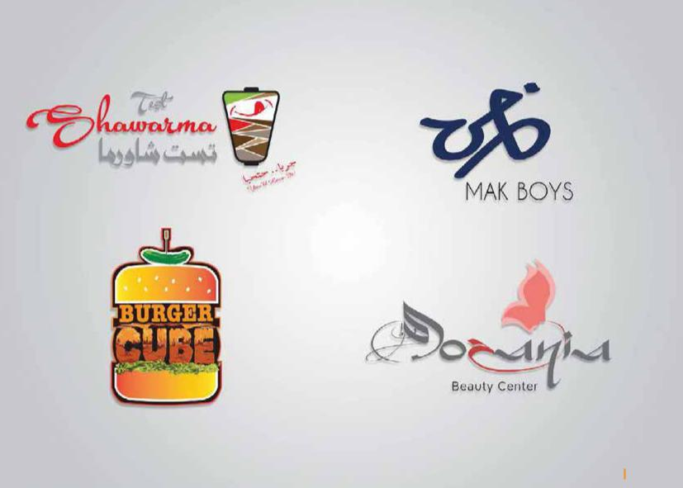

LOGO

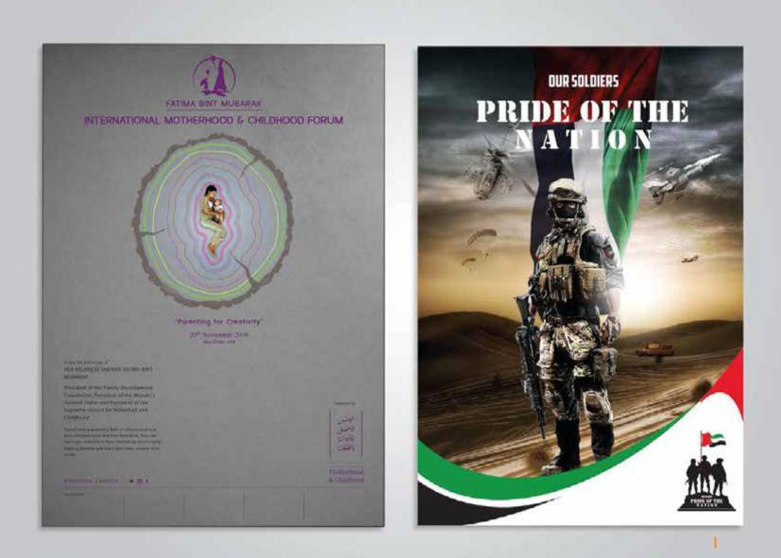

POSTER

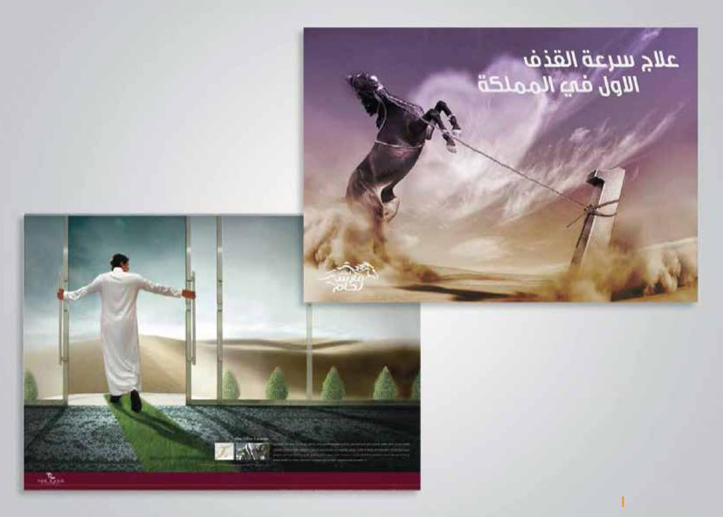

E-MAILER AD

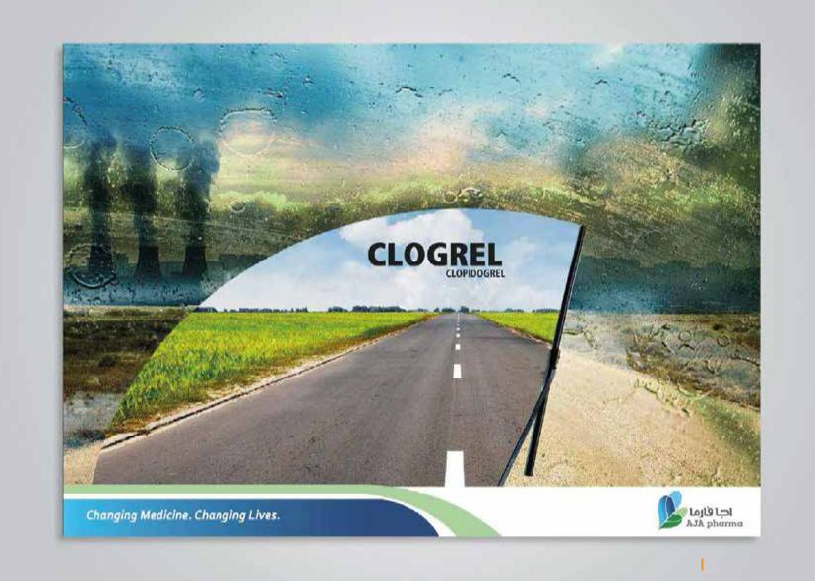

NEWS PAPER AD

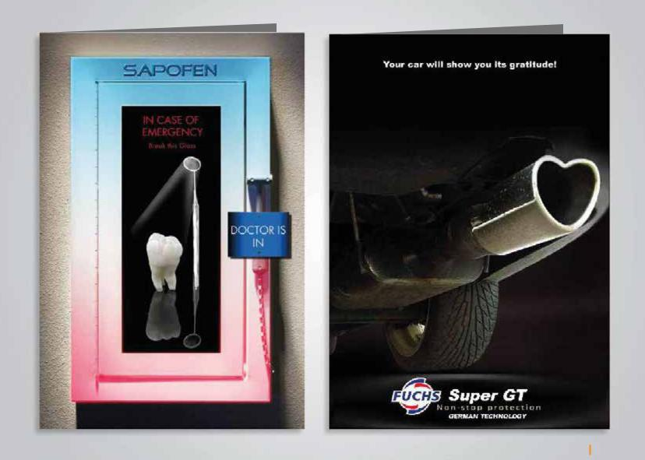

LEAFLET

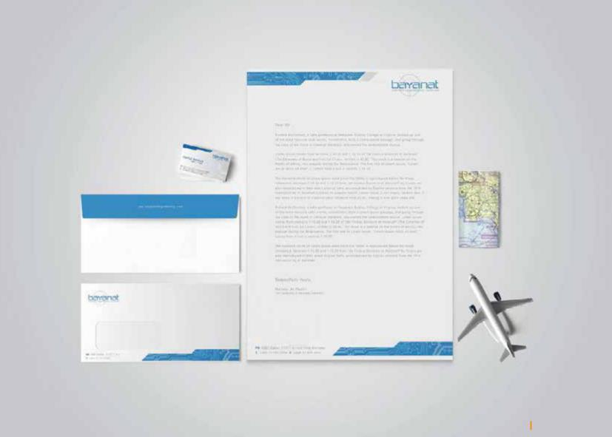

STATIONERY

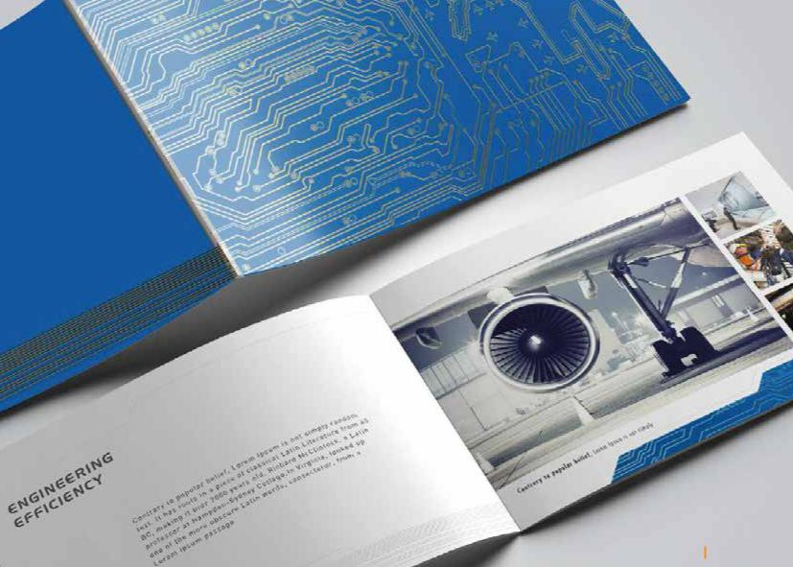

BROCHURE

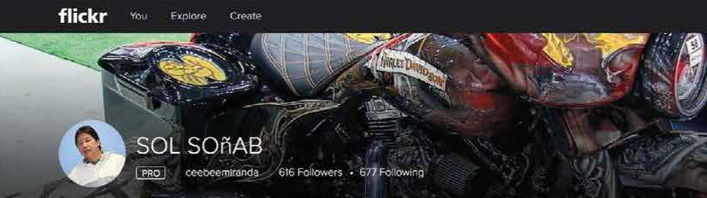

Photography

