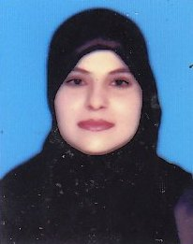
CURRICULUM VITAE

LAILA
C/o-Contact#. +971502360357
Email # laila.341152@2freemail.com

OBJECTIVE:
Want to work in challenging environment to enhance capabilities under senior persons and esteemed organization. To excel and contribute to the best of my abilities in an organization which offers opportunities for growth.
QUALIFICATION:

- M.SC (Sargodha University Punjab Pakistan 2014.)
- B.Ed (Allama Iqbal Open University Islamabad Pakistan 2012.)
- B.A (Allama Iqbal Open University Islamabad Pakistan 2009. )
- F.A (Rawalpindi Board Pakistan 2006.)
- SSC (Rawalpindi Board Pakistan 2004.)
EXTRA QUALIFICATION:
- 3 Months IELTS Course.
- 6 Months Beautician Course.
- 3 Months Basic Computer Course in Creative Computer Institute Rawalpindi.
- 6 Months English Language Course.
EXPERIENCE:
- 3 Years Worked as a“Receptionist” in Pearl Continental HotelRawalpindi Pakistan from the date 04-02-2009 to 06-02-2012.
- 6 Months Worked as a “Teacher”inAllama Iqbal Public School Rawalpindi Pakistan.

Communication Skills:
- English, Urdu, Punjabi.

PERSONAL DETAILS:

Date of Birth 01-06-1986
Nationality Pakistani
Place of Birth Rawalpindi Pakistan
Passport Expiry 08 August 2017
Date of Issue 09 August 2012
Marital Status Married

