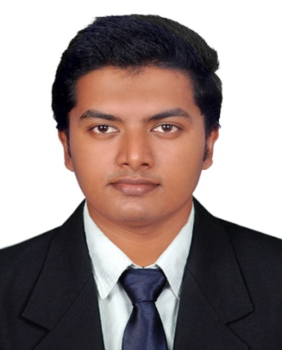
VISHNU
VISHNU.341157@2freemail.com
B. Tech in Mechanical Engineering .

CAREER OBJECTIVE:

To obtain a challenging and rewarding position in a growth oriented organization, where my acquired skills and knowledge can be utilized in achieving organizational and personnel goals.

PROFESSIONAL EXPERIENCE:

- Worked as Mechanical Estimation Engineer at CAPITOL GROUP OF COMPANIES - Pvt-Ltd from August 2016 to January 2017.

- Asst.Site Engineer at THYSSEN KRUPP INDIA-Pvt-Ltd for BPCL Kochi expansion project from August 2015 to July 2016.

Job profile :
- Study and analysing the design, drawings, specifications and necessary tender documents for the assigned Tender.
- Preparation of enquires and floating the same to the specified suppliers/ manufacturers.
- Raise necessary queries to fulfil the system to review with Sr. Estimator.
- Follow up the supplier and to respond to their queries to obtain quotation in the proper time.
- Prepare the costing and BOQ sheets as per the drawings, specifications and tender documents.
- BOQ preparation of MEP projects.
- Quantity take off from the projects.

Experience Summary
1. Designation: Mechanical Estimation Engineer
Projects Handled:
1.Name :Amina Residence Building (G+4P+15 Floor)
consultant :Inspiration Consulting Engineers, Dubai.
2.Name :Park Inn JVT (B+G+4P+25 Floor )
consultant :ZAS Group of companies, Dubai.
3.Name :Outlet Mall Expansion
consultant :Al Manhal Engineering Consultants(AMEC), Diera Dubai

Responsibility
- Understanding the Drawing, Specifications, BOQ, Contract Documents & scope of projects.
- Quantity take off from the drawings which includes Drainage, water supply, Duct, Chilled water pipes, Fire system pipes etc.
- BOQ preparation.

2. Designation : Asst.Site Engineer
Project handled : Coke Handling System Package,BPCL Kochi
Responsibility
- Understanding the Drawing, Specifications, BOQ, Contract Documents & scope of projects.
- Erection and assembly of circular stacker reclaimer(650TPH) for coke storage.
- Work on both pipe conveyors and belt conveyors.

Academic Qualifications:
- B. Tech in Mechanical Engineering from Kerala University, India in the year of 2011-2015.
- Diploma in Mechanical Building construction Engineering.(HVAC, Plumbing, Fire Fighting )

Skills & Expertise:
- Excellent command over in MS Word & MS Excel packages of MS Office.
- Ability to complete assigned task with in stipulated time period.
- Excellent grasping power and ability to learn more.
Software Skills:
- Drafting Softwares- AUTOCAD , REVIT,SOLID EDGE.
- Estimation Software- PLANSWIFT
- Microsoft Office

Personal Qualities:
- Excellent oral and written communication with people at all levels.
- Ability to prioritize and manage time effectively
- Highly motivated and aggressive
- Hard working and goal oriented
- Excellent team worker with an ability of a potential team leader.
- Well-versed in establishing and maintaining long term relationships.

Personal Details:
Date of Birth : 08 March 1993.
Nationality : Indian.
Marital Status : Single.
Languages : English, Hindi, Malayalam,Tamil.
Valid Driving License : India.

Declaration:
I hereby declare that the statements furnished above are true and correct to the best of my knowledge and belief.

