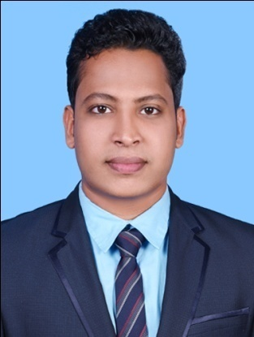

JITHIN
Email: jithin.341225@2freemail.com

CUSTOMER RELATIONS-SALES AND MARKETING EXECUTIVE

CAREER OBJECTIVE
Strongly dedicated and reliable Sales and Marketing Executive with an outstanding client satisfaction history and superior work ethic. Adept at functioning well as an independent worker with little to no supervision or as part of a retail executive management team. Especially skilled at maintaining superb relationship networks with clients vendors and all levels of staff with a high degree of courtesy and professionalism.

CORE QUALIFICATIONS AND PROFESIONAL SKILLS
- Over 4 years of experience as in the field of Sales and customer relations
- Outstanding people skills
- Negotiation skills
- Creative, insightful, innovative, assertive
- Leadership – result oriented and goals achiever
- Efficient under pressure
- Strong knowledge of channel sales management and direct sales principles and practices
- Superior facility with selling solutions related to mergers and acquisitions

PROFESSIONAL EXPERIENCE

Pearson Education Services Pvt.Ltd.
05-08-2015 to 23-01-2017
Sales and Customer Relations
- Reached sales quotas and financial objectives on a regular basis.
- Maintained sales pipeline records and updated as required.
- Performed troubleshooting to anticipate account complications and client queries.
- Maintained and updated relationship maps for current and prospective clients.
- Conducted research on current retail industry services trends and news.
- Assisted with training staff in integrated marketing solutions.
- Expanded client base through cold calling to qualified prospective customers.
- Assisted in developing pipeline for new retail business opportunities.
- Evaluated business and industry requirements for each existing and prospective account.
- Managed and maintained key strategic client relationships.
- Fostered and sustained important successful business partnerships.

Crown plaza Doha The BussinessPark, Qatar.
19-09-2013 to 13-03-2015
Guest Service Associate
Hilton World Wide,Chennai,India.
12-05-2012 to 15-05-2013
Guest Service Associate
The Raintree Hotel,Chennai,India.
11-05-2011 to 30-09-2011-Industrial Exposure Training

EDUCATION QUALIFICATION
Bachelor of Science : Hotel Management
2009-2012 Bharathiar University
MBA. Operations and Project Management (Result Waiting)
2014-2016 Madurai Kamaraj University

KEY RESPONSIBILITIES HANDLED
- Responsible for the supervision of a staff of 88 people within the customer service department
- Performed market research surveys amongst client base to seek feedback on sales techniques, follow-up methods and quality of after sales service
- Improving customer service based on client feedback through the development of new policies and procedures Successfully handled all public relations issues
- Provided support to the sales team, ensuring all sales and service objectives were met
- Assisted in the development of new policies and procedures
- Performed market research surveys on customer needs and requirements
- Prepared weekly sales reports for the sales team and sales management
- Generated repeat business through successful client follow-up
ACHIEVEMENTS
- Developed strong relationships with managers and staff, creating a cohesive and productive team within a deadline-driven environment..
- Cultivated excellent long term relationship with clients, maintaining on going communication and facilitating solutions to address concern.
.

PERSONAL PROFILE

Date of Birth : 21.01.1990

Sex : Male
Nationality : Indian

DECLARATION
I hereby declare that all the above furnished details are true and correct to the best of my knowledge.

Place: United Arab Emirates ( JITHIN.N )

