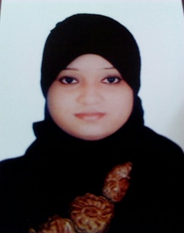 | Amrin  Amrin.341226@2freemail.com
Objective | To obtain a creative and challenging position in an organization that gives me an opportunity for self-improvement and leadership, while contributing to the symbolic growth of the organization with my technical, innovative and logical skills
Skills & Abilities | Strong motivational and leadership skills.  Ability to produce best result in pressure situation.  Excellent communication skills in written and verbal both.  Ability to work as individual as well as in group.  Proficient on computer skills specifically MS Word, Excel and PowerPoint.
Experience | Customer Service Agent at Emirates Airlines  March 2010 – November 2010  Mumbai International Airport, India.  - Prepares for customer inquiries by studying products, services, and customer service processes.  - Responds to customer inquiries by understanding inquiry; reviewing previous inquiries and responses; gathering and researching information; assembling and forwarding information; verifying customer's understanding of information and answer.  - Records customer inquiries by documenting inquiry and response in customers' accounts.  - Improves quality service by recommending improved processes; identifying new product and service applications.  - Accomplishes customer service and organization mission by completing related results as needed.  Office Administrator at Sangita Institution.  February 2008 – November 2008  Mumbai, India  - Updating and maintain database such as mailing lists, contact lists, and client information.  - Co-ordinate and organize appointments and meetings  - Retrieve information when requested.  - Dealing with queries on the phone, by email and social media.  - Assists in the preparation of department budget and expenses.  - Resolves administrative problems by Coordination Preparation of reports, analyzing data and Identifying Solutions.
Education | B. Com (Bachelor of Commerce in Accounting), Mumbai University  Diploma in Office Automation Accounting Package Tally at St. Angelo’s Computer Education, Mumbai, India  Diploma in International Airline and Travel Management at IITC, Mumbai, India  Training for CSA at Mumbai, India

Personal Information
Date of Birth: 8th April 1989
Languages: English, Urdu, Hindi and Marathi
Civil Status: Married
Visa status: Residence Visa (Husband Sponsored)

