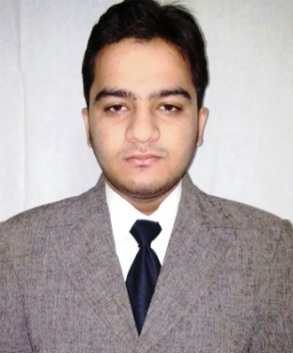
RESUME

Asim
Dubai,U.A.E.
C/o-Mobile - 971-504973598
E-mail: asim.341229@2freemail.com

OBJECTIVE:

Seeking a position in a dynamic business environment where my experiences and abilities can be used to benefit the company. Prefer working with teams while having the ability to remain focused on tasks. I’m committed for applying the new technologies, with innovation thinking, and following up the latest techniques.

STRENGTH:

Eagerness to do & learn more, capable to take every opportunity as a challengeable to work with minimal supervision and as a cooperative team member, handling many tasks simultaneously. Self-confidence & connection concentration committed to achieving outstanding results. Strong communication, leadership, planning, management and problem solving skills.

SPECIALIZATION in Accountancy:

- Tally ( All Version )
- Busy win (Accounting Software)
- Accounting on Excel

WORKING EXPERIENCE:

Organization : Govind Ram Jewellers
Location : Lucknow, India
Designation : Accountant
Duration : Jan-16 to Jan -17

Organization : Blue Cross Agency
Location : Lucknow India
Designation : Accountant
Duration : Apr-13 to Dec 15.
DUTIES & RESPONSIBILITIES :
- General A/c related work such as preparation of vouchers, record Keeping and accounting transactions.
- Petty Cash Management & Cash Reconciliation Statement I.e. Inward & Outward Statement.
- Bank Reconciliation & ledger Account Reconciliation.
- Vender / Client Reconciliation Statement.
- Maintain Inventory Record on Computer and physical.
- Generating Sales Invoices.
- Follow Up with Local Bank for Banking Transaction.
- Entries of cash Book, Sales Bills & Purchase Bills etc.
- Making Cheque’s for parties.
- Deposit All Cheque/Cash bank.
- Maintain Ledger for Sales, purchase with VAT.
- Preparation of Day Book.
- Monitored daily bank balances through internet banking and prepared daily Bank Statements.
- Making Reports as per Management Requirement.
- Making Finalizing Reports I. e. Profit & Loss, Trail Balance & Balance Sheet.

ACADEMIC QUALIFICATION:

- Graduated in B.Com-2016
- Matriculation from ISC Board- 2013.
- Higher Secondary from ICSE Board - 2011.

PROFESSIONAL QUALIFICATION COMPUTER SKILLS:

- Tally Financial Accounting Program (From Tally Academy MFCS).
- M.S. Word, Excel, Microsoft Outlook Express & expert in Internet surfing.
- Practically having strong & hardcore experience in computer networking

PERSONAL Details:

Date of Birth : 21st January 1995
Marital Status : Single
Languages Known : English and Hindi
Hobbies : Developing professional network & Cricket

