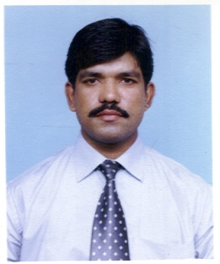
NASIR
Nasir.341271@2freemail.com
C/o-Mob: +971505891826
OBJECTIVE:

To have a challenging career as a Sales Executive and to continue my career advancedment using new technique and modalities.

QUALIFICATION

Higher Secondary : Faisalabad (1992)

PRESENT STATUS:

I worked as a Area Sales Manager in Lab Links.

Experience:

S. S. DIAGNOSTICS March 1995 to August 1998

Worked as Office Assistant

Duties and Resposibiliites

- Organize office and assist associates in ways that optimize procedures
- Sort and distribute communications in a timely manner
- Create and update records ensuring accuracy and validity of information
- Schedule and plan meetings and appointments
- Monitor level of supplies and handle shortages
- Resolve office-related malfunctions and respond to requests or issues
- Coordinate with other departments to ensure compliance with established policies
- Maintain trusting relationships with suppliers, customers and colleagues
- Perform receptionist duties when needed

LAB LINKS October 1998 to Dec 2016

Worked as Office Asistant and Sales Executive
Duties and Resposibilities
- Visit potential customers for new business
- Provide customers with quotations
- Negotiate the terms of an agreement and close sales
- Gather market and customer information and provide feedback on buying trends
- Represent your organisation at trade exhibitions, events and demonstrations
- Identify new markets and business opportunities
- Record sales and send copies to the sales office
- Review your own sales performance
LANGUAGE KNOWN:

Urdu, Hindi, Punjabi and English.

COMPUTER SKILLS:

Word, Excel, email.

PERSONAL DETAILS:

Date of Birth : 05-02-1974
Nationality : Pakistani
Marital Status : Married
Visa Type. : Visit

Nasir

