Curriculum Vitae
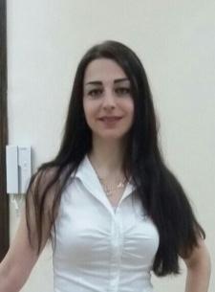

Profession : Mechanical Engineer (Marine)
Graphic Designer
Name : Vivian
Nationality : Syrian
Marital Status : Married
Date of Birth : 22/05/1983
C/o-Contact No. : +971502360357
E-mail address : Vivian.341289@2freemail.com

EDUCATIONAL QUALIFICATIONS:

Degree obtained : Faculty of Mechanical Engineering
Bachelor (BSc) (Marine Engineering
Department), GPAGood

Degree obtained from : Syria, TishreenUniversity

Year of Passing :2007

Courses: 1- Illustrator program 2016
2- Photoshop Program 2016
3- Painting Course in progress

SUMMARY OF EXPERIENCE:

- Marine Engineering:
Since 2009 up to date I have been working at Lattakia port company \ planning department \. I worked as head of planning section for about two years. my job gave me someacquaintances about containers, arranging containers at squares, shipping and port equipments.

Duties of planning section: studying port productivity plan annually, making sure that all projects are going perfectly and trying the best to keep the annual plan going as it planned to
keep port profits at high levels.
In addition to translate (contracts, Emails, Tenders and correspondence) English to Arabic.

- Graphic Designing: I consider myself a talented person, and I have always been attracted to art so I did complete some courses and I hope to gain experience in this field by learning and working.

SKILLS:

Languages:
Arabic (Mothertongue)

English (Very good in Speaking, Writing. Reading)

I had English courses at Aleppo university and the British consular in Lattakia

Level:advance six.

IT skills:MS Office
MS Project
AutoCAD

Driving License: UAE and Syrian

Hobbies: Drawing
Reading (English and Arabic)
Social media (Facebook, twitter, Instagram, google)

