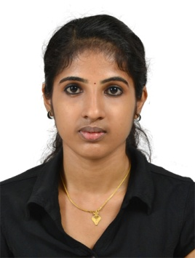

ASWATHI

Email: aswathi.341294@2freemail.com  +971505891826

CAREEROBJECTIVE

To obtain a challenging,satisfying and brightcareerin an esteemed organization with good working environment,whereIcan fully utilizemy experienceandcapabilities to enhancemy area of Financemanagement efficiency this canexhaustively test my expertise.Iwant to be associated with an organization whereIcan prove and exploremy abilities forthe
developmentof the organization.

PROFESSIONAL EXPERIENCE

NEHA SALES CORPORATION

ACCOUNTANTAUGUST2013-SEPTEMBER2014

AccountantcoordinatingallfinanceactivitiesbeingseatedintheofficeinErnakulum
(Kerala)

Objectivesoftherole:

Maintaining basicaccounts,book keeping.

Handling petty cash forthe local purchase.

Maintaining Reconciliation of bank statement

Ledgerentries,journalentries,invoiceentriesand crosschecking.

Preparing and analyzed financial statement.

Preparing daily purchasereport

Preparing balancesheet.

Monthly profit&loss Account.

SALES TAX CONSULTANCY CENTRE,B.B COMPLEX,SOUTH BAZAR,KANNUR

ACCOUNTANTNOV2014-July2016

⬥ | Maintaining basicaccounts.
⬥ | Entering of Purchases inTally System
⬥ | Entering all the payments againstpurchases.
⬥ | Preparation all types of Bank Payments on routine basis.
⬥ | Entering of Sales in Tally system outlet wise
⬥ | Checking the Cash Deposits asperSales and entering in Tally system
⬥ | Checking and preparation the payments ofPettyCash.
⬥ | Reconciliation of all the Bank Accounts
⬥ | Preparation Sales Report
⬥   | PreparealltypesofPaymentsi.e.,SecuritydepositRefund,maintenance, charges and Electricity&Wateretc.  Calculation of monthly return | Service
⬥ | Making on-linepayment of SalesTax

EDUCATION&CERTIFICATIONS

Bachelorof Commerce (B com)

Highersecondary education in COMMERCE

Page2 of3

OFNOTE

Operating System:Windows Xp,Windows 7

→ ExtensiveknowledgeofOfficeproductivitysoftware(MSWord,MSExcel,MSPower- point)
Accounting Software : Tally(ERP 9)

PERSONAL DETAILS

Date of Birth :15 Sep 1992

Marital Status :Married

Languages Known :English,Malayalam and Hindi

Visa Status : Visit visa

Strengths:

Adaptability

Hardworking

Honest

Flexibility

Optimistic

Fastdecisionmaking

Persistence

Self motivated

DECLARATION

I certify that,to the best of my knowledge and belief,all the information attached to this application is true,correct and complete and made in good faith.

ASWATHI
Page3 of3

