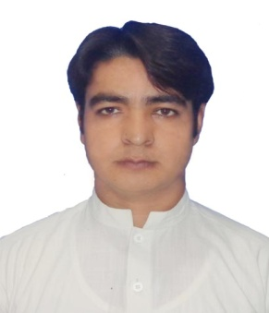
NASIR
Nationality: Pakistani
Domicile province & city: KPK & Karak
C/o-Cell: +971504973598
Email: nasiri.341311@2freemail.com
OBJECTIVE
To utilize myself efficacy and all my skills in order to work well and effectively in new and challenging communicating environment for the sake of achieving organizational goals and to promote team work.
Core Competencies
- Planning and organizing
- Communication skills
- Problem analysis and resolution
- Judgment
- Decision-making
- Attention to detail
- Team player
Major courses:
- Accounting
- Cost Accounting
- Business finance
- Business math
- Corporate finance
- International business finance

Working experience Total 1year 10 months
- CA firm Account Assistant 1year 8months 05Mar,2012 to 30 Nov 2013
Job Responsibilities
- Filing, typing, basic bookkeeping, handling mail and making phone calls.
- Ensuring all payments amounts & records are accurate.
- Assisting qualified Accountants with audits.
- Working with journals, sales & purchase ledgers and spreadsheets.

- Bank of Khyber As internee 2months 08 Aug-10 Oct ,2011
Job Responsibilities

- Account opening
- Remittances
- Deposits
- Customer care
- Data entry in software

ACADEMIC QUALIFICATION

Degree | Ms management sciences Awarded in 2016(April)
University | Islamia College Peshawar (Public Sector University)
Session | 2013-15
CGPA/ Division | 3.76 CGPA
Major | Management Sciences (management)

Degree | BBA Hons. (16 years.) Equivalent to MBA
University | Islamia College Peshawar (Public Sector University)
Session | 2008-12
CGPA/ Division | CGPA 3.08/4, 1st Division, or 77%
Major | Finance and Marketing

Certificate | HSSC (Fsc. Pre Engineering)
Institute/Board | Vision Builder science college Ghundi kalla karak/ BISE Kohat
Session | 2007-08
Division | 1st Division (831/1100) ,or 76%
Major | Math ,Physics, Chemistry

Certificate | SSC
Institute/Board | Paradise Public school Dabb Karak/ BISE Kohat
Session | 2005
Division | 1st Division (819/1050) or 78%
Major | Science

WORKSHOPS/ SEMINARS/ CONFERENCES:-

S.No | Title | Organizer | Location | Date
1 | Conference on Pakistan granting MFN status to India. | Department of  Management Sciences,  Islamia College  University, Peshawar. | Islamia College  University,  Peshawar, Pakistan. | June 20,  2012
2 | 1st Asian Business Research Conference | ASMMR and Islamia College Peshawar | Islamia College  University,  Peshawar, Pakistan | 8-9 September 2012
3 | First Abasyn International Conference on Technology and Business Management | Abasyn University Peshawar and Islamia College Peshawar | Abasyn University Peshawar and Islamia College University Peshawar | 3-4 April 2013

Technical skills
- MS Office
- Software based accounting entries
- Excellent knowledge of generally accepted accounting principles
- Knowledge of regulatory standards

HOBBIES AND INTEREST
- Reading Books
- Playing Cricket
- Surfing Net
- Reading News paper
- Watching Talk Shows

LANGUAGES:
- English: Fluent
- Urdu: Fluent
- Pashtu: Fluent
REFERENCES

- References will be provided on request

