

Contact HR Consultant for CV No: 2047932

E-mail: [response@gulfjobseekers.com](mailto:response@gulfjobseekers.com)

Website: <http://www.gulfjobseeker.com/employer/cvdatabasepaid.php> 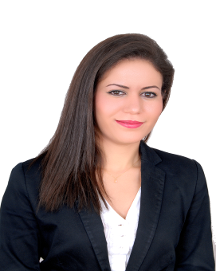

**Date of birth :** 30 may 1984

**Civil status** : Single

**Nationality** : Moroccan

**Driving license** : UAE 2016

***LANGUAGES***

**ARABIC :** Mother tongue

**ENGLISH:** Fluent

**FRENCH:** Fluent

***OBJECTIVE***

To grow professionally through continuous education in working and promote company's excellence through highly competitive services

***CERTIFICATS AND DIPLOMATS***

**2008:** Computer certificate from national aviation`s institute

**2007:** University degree (License) in a private law in French at faculty of judicial sciences, economics and socials

**2002:** Bachelor mathematical science

***WORK HISTORY***

**Sales executive and Makeup artist June 2014 to present;**

**Group Abu Dhabi U.A.E.**

* Assist the customers in meeting their needs.
* Provide customer with product information and clear idea about the Brand.
* Prepare production and status reports on a weekly basis to the manager.

**Sales executive October 2009 to April 2014;**

**DUTY FREE shop Morocco Airport and U.A.E. Airport**

**Beauty, watches jewelries and bags**

* Introducing the brands enjoy the highest brand loyalty of all consumer products.
* Assist the costumer in meeting their needs.
* Give advice and be guidance for customer on product selection.
* Guaranty cross selling of products and achievement of the sales goals.
* Cashiering, accepting payments through credit cards & cash or in any currencies

**Sales associate 2008-2009:**

**Fashion at ZARA shop Morocco**

* Responsible for updating revised price based on the system and changing barcodes with accordance to head office.
* Responsible in filing necessary documents like office memo, monthly statements and daily sales report.
* Responsible for requisition, organizing, recording, filing & encoding of external/internal transactions.
* Responsible for thorough checking of deliveries, inventories, receiving invoices, quality and quantity of items
* Cashiering.

**Receptionist at hotel ATLANTIC PALACE 2007-2008 Morocco**

* Answering and managing calls and jotting important information and email
* Maintains the confidentiality of records so as to keep the secrecy of the company.
* Prepares production and status reports on a daily basis to the manager.
* Assists the clients in their inquiries of available rooms and promotion days

***SKILLS:***

➢Proficient in Using Microsoft Word, Excel and excellent communication skills.

➢Quick learner, team worker, dynamic, adaptive to situation and capable of performing under pressure.