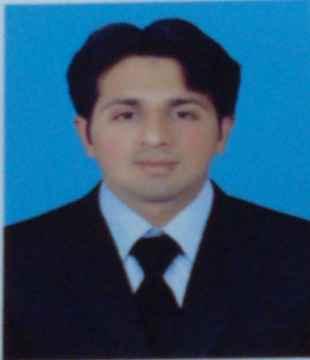
Muhammad
Muhammad.341333@2freemail.com

Career Objective:
To secure a position in an organization that would fully employ my personal & professional duly skills of Software Engineering, Computerized Accounting and Networking as well as my academic training in rewarding career that affords growth.

Educational Background:
University of the Sargodha
Session 2013 - 2015
- M.Sc. IT(software Engineering )

Shiblee College of Commerce Gujranwala
Session 2009-2011
- B.Com (Commerce)

Government College Satellite town Gujranwala
Session 2006 - 2009
- F.Sc (pre-Engineering)

Government M.T High School People colony Gujranwala
Session 2004- 2006
- Matric (Science)

Employment Experience
- Lecturer
Allama Iqbal Open University approved study center Paptech College Gujranwala
From December 2015--- till
During my job I have taught following courses
Management Information System (MBA 1st)
- Lecturer
Paptech College Gujranwala
From December 2015--- till
During my job I have taught following courses
Microsoft Office
Peachtree
Asp.net

- Lecturer as visitor
Greenz College Gujranwala
From September 2015 to February 2016
During my job I have taught following courses
programming
Basic Electronic
Modern programming
Web programming
- Science and Commerce Teacher
Muslim Ideal Science and Commerce College Mandalay
From April 2011 to May 2013
During my job I have taught following courses
Computer Science
Introduction to business
Cost Accounting
Business Math

Projects Successfully Completed

- Final Year Project: University ExaminationSystem, a web application in ASP.NET using C# Language, which automate the manual system of Examination Department of University of Sargodha Gujranwala Campus.
- Semester Project: “Library Management System” in Object Oriented Programing using C++ Language.

Computer Skills:

- Command on Java, PHP, C++ and C# languages.
- A hands on experience of Designing using HTML5, CSS andJava Scripting.
- Design, Test, and Develop Software to Meet User Needs.
- Ensure Software Functions Normally Through Software Maintenance and Testing.
- Estimate Project Cost& Scope of Project
- Knowledge of Web technologies.
- Command on database management system, Microsoft SQL server.
- Excellent object-oriented design and programming skills.
- Fully command to manage accounting Records in computerized Software as Peachtree.
- Fully command in Microsoft Office management.

Personal Skills:

- Ability to work independently as well as in a team oriented environment.
- Ability to learn processes and systems quickly.
- Ability to learn and adapt to multiple development environments.
- Effective communications skills.
- Committed to the timely delivery of a job well done.
References:

Reference will be published on the Demand.

