GEMMA
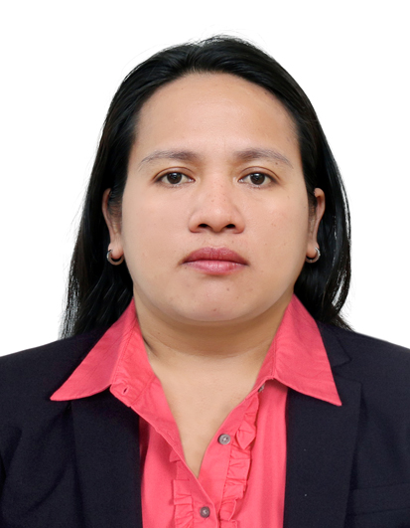
RMT,ASCPi,HAAD- MLT
C/o-Mobile phone: +971-501685421
Email address: gemma.341345@2freemail.com
OBJECTIVE:
To join a new organization and contribute to the achievement of its goals and objectives.

PROFESSIONAL SUMMARY:
- Can work independently, task- focused, result- oriented and a team player.
- Excellent skills both in Phlebotomy and Microscopic analysis and handling machines.
- Skilled in maintaining safety for blood collection and handling.
- Experienced in venipuncture and capillary puncture techniques.
- Well- experienced in Clinical Diagnostic Laboratory both in Tertiary Teaching Hospital and Diagnostic Polyclinic setting.
- Basic Life Support-certified .

WORK HISTORY
Al Borg Medical Laboratories
Position: Phlebotomist/ Medical Technologist
Unit No.201, Bin Sedira Bldg. Khalifa Bin Zayed St, Al Ain, Abu Dhabi
Date Employed: June 29, 2016- October 25,2016

Al Noor Hospitals Group.
Position: Phlebotomist
Al Bateen branch
Date Employed: April29,2014- April29, 2016

University of the East Ramon Magsaysay Memorial Medical Center Inc. (UERMMMCI)
Position: Medical Technologist
No.64 Aurora Boulevard, Brgy. Doña Imelda, Quezon City, Philippines.
Date Employed: July 5, 2010- May15, 2013

De La Salle Health Sciences Institute (DLSHSI)
Position: Medical Technologist
Dasmariñas, Cavite Philippines
Date Employed: August 1, 2008- July 18, 2009

Centralle Medical Diagnostic and Polyclinic Inc. (CMDP Inc.)
Position: Medical Technologist
G/F First AMIJI Mansion 6th Ave.,Cor.M.H.Del Pilar St., Caloocan City, Philippines
Date Employed: October 16, 2006- December 10, 2007

The New Quezon City General Hospital Consumers Cooperative Laboratory
Position: Medical Technologist
Seminary Road, EDSA, Quezon City, Philippines
Date Employed: August 19, 2004- 30 April 2006

LICENSE DETAILS: License no: Date issue: Validity:
REGISTERED MEDICAL TECHNOLOGIST 46532April 5,2004 May 2, 2019
ASCPi Certificate - August2013August2019
HAAD-MLT (for reregistration)

EDUCATION
Bachelor of Science in Medical Technology1999-2003
Manila Central University, Caloocan City Philippines

DEPARTMENT DESIGNATION:
- HEMATOLOGY
- CLINICAL CHEMISTRY
- CLINICAL MICROSCOPY
- PHLEBOTOMY
- BLOOD BANKING

JOB RESPONSIBILITIES:
PRE -ANALYTICAL PHASE
- Identify the patient correctly.
- Patient education by giving appropriate instructions and preparation prior to start any lab. procedures.
- Preparing the working area by maintaining cleanliness and infectious controlled environment.
- Ensures proper documentation upon receiving samples and rejections, preparations and its transport.
- Securing the adequacy of lab. supplies by monitoring of its consumptions and schedule of requisition.
- Retrieve of laboratory requests thru LIS.
ANALYTICAL PHASE
- Documentation and preparing the analytical equipment or machines thru running of internalcontrols, and proper maintenance to ensure the accuracy and precision of results.
- Do the exact procedure, identify the cells, parasites and other organism, urine crystals and cast, and utilize the correct formula for counting cells and computation of analytes.
- Get involved in amendment of policies, as to comply the accreditation requirement.
POST ANALYTICAL PHASE
- Releasing of result promptly and verified.
- Notify the requesting physician for critical values.
- Storing and sorting the sample for retention and schedule for disposal.

FOR BLOOD BANKING

reening, and blood screening, blood component preparation such as
PRBC, Platelet conc., FFP. Cryoprecipitate, and compatibility testing,
Phlebotomist.
blood component preparation such as
PRBC, Platelet conc., FFP. Cryoprecipitate, and compatibility testin
- Phlebotomist.
- Donor screening, and blood screening, blood component preparation such as
PRBC, Platelet conc., FFP. Cryoprecipitate, and compatibility testing.

Machine used:
- SYSMEX K-21(CBC), SYSMEX ca500 series (Coagulation)
- EASYLITE plus (electrolyte), BT1500 plus (clinical chemistry.), BIORAD-D10(HgbA1c)
ROCHE9180(electrolytes), COBAS 411(Hormones), COBAS INTEGRA 400PLUS(chemistry), CELL-DYN RUBY(ABBOT)-hematology, AXSYM (Abbott),
Dia MED (cross matching and coombs test)

SEMINARS/WORKSHOP
- VPS-PENN MEDICINE International Diagnostic Radiology&Med.Lab Conference
May 19-20,2016 Rosewood Hotel, Abu Dhabi,UAE
- Arab Health Congress MEDLAB 2016 Conference on Laboratory Management
January 25,2016 at Dubai International Convention and Exhibition Centre, Dubai, UAE
- Basic life Support(BLS) Training
January 7,2016 at Al Noor Hospital-Airport Road Branch, Abu Dhabi, UAE
- Fire and Safety Training/Hazmat Management
June 22,2015 at Al Noor Family Clinic-Al Bateen Branch, Abu Dhabi, UAE
- Continuing Medical Education -10 units
January 2014- December 2015 at Al-Noor Hospital, Abu Dhabi, UAE
- Medical Technology Internship Training
April 1, 2002-March 31, 2003, Veterans Memorial Medical Center
Quezon City, Metro Manila, Philippines.

