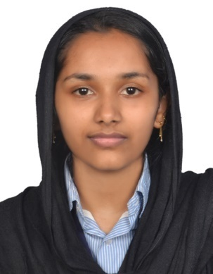

SHEMEELA
Email: shemeela.341356@2freemail.com

C/o-Phone: +971 502360357

OBJECTIVE:

To pursue a challenging career and to be part of a progressive organization that gives scope to enhance my knowledge, skills and to reach the pinnacle in the professional work driven environment with sheer determination, dedication and hard work.
ACADEMICS

- EDUCATION

QUALIFICATION | SCHOOL/COLLEGE | BOARD | YEAR OF PASSING | STREAM | SCORE
Under Graduation | Ilahia college Of Engineering and Technology-Muvattupuzha | AICTE  MG University | 2016 | B.TECH  CSE | 7.1
HSE | ST.Marrys HSS Vellaramkunnu | Kerala State | 2011 | Science | 80%
Class X | Fathima HS ,Mlamala | Kerala State | 2009 | General | 82%

2. Software Skills

Programming | C, C++(including Data Structures) , Java, HTML
Languages:
Operating Systems: | Windows, UNIX
Database Programming: | SQL

3. Projects

- Did a project on Image annotation by latent community detection and multikernal learning as a part of my final year Project, where a keyword or image name was taken as an input, and searching in the database and display the images, which are widely used in different browsing sites.
- Did a project named gimmie a lift which is an online vehicle sharing website.

ACADEMIC INITIATIVE:

- Attended one day workshop on “Ethical Hacking” conducted by Mr. Ankit Fadia (on 26 th September 2015).
- Attended one day workshop on “Web Development” conducted by Mr. Jeo Joseph(CEO Cruxsys Technology)
- Paper presentation on the topic “Secure Data Retrieval for Decentralized Disruption-Tolerant Military Networks”.

EXTRA CURRICULAR ACTIVITIES:

- Member of department association in college level and class representative in school level.
- Coordinated different events done on college.
- Member of Junior Red Cross district squad in school level.
- Represented sub district recitation, singing and dancing competition and won 1 st price in subdistrict level.

Personal Details

Date of Birth | : 12-04-1994
Age | : 22yrs
Sex | : Female
Marital status | : Single
Languages known | : English, Malayalam, Hindi, Tamil.
Hobbies | : Reading, arts,coocking,travelling.

