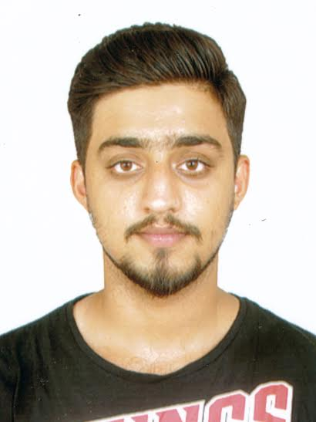
Contact HR Consultant for CV No: 2048172
E-mail: response@gulfjobseekers.com
Website: http://www.gulfjobseeker.com/employer/cvdatabasepaid.php
Objective:
To pursue a profession in sales, marketing and related fields. Enthusiastic & zealous to achieve the best in the service industry.
Personal details:
Date of birth: 29 august 1992
Nationality: Indian
Gender: Male
Educational qualification:
Appeared for CAT(Common admission test) – 29th Nov, 2015
Pursuing, Bachelor of Commerce from University Of Allahabad (final year).
Higher school certificate (HSC)- COMMERCE- 66.6% NIOS-2012
SECONDARY SCHOOL CERTIFICATE (SSC)- 54% CBSE 2010
COMPUTER SKILLS:
MICROSOFT WORD, EXCEL, POWER POINT
Surfing the net and various programmes on computer
WORK EXPERIENCE:
Worked at Real Estate Company (01/11/2016-till date)
As a leasing executive
Handling customer enquiry over the phone and fixing appointment as per the customer needs of the apartment or villa all over Abu dhabi
Following up on daily basis with the client and updating the CRM
Finding the best suitable location and sizes for the clients and giving the best service and availability to the client
Making reports end of the day to be submitted everyday to the manager regarding the meeting and viewing made with the customers
Worked at intelenet (call center) (1/01/2015 till 30/09/2016)
As a senior customer sales and service executive
Role in the company:
Receiving calls from overseas (Australia) regarding customer query over their gas and electric bill. Keeping a keen follow up with the customers for getting the payment done . Making reports on a daily basis regarding the work done and he sales made .
Products of lumo energy also sold to customer that would benefit the customers
Worked at LIC (Life Insurance Corporation of India)(8/01/16 – 15/04/16)
As Telesales Executive and Field Executive
Telesales duty:
Calling customers and detailing the customers about the insurance policy and fixing appointments. Customer follow ups on phone and emails. Keeping excel up dated regarding the presentations follow ups lead created on daily basis. Building a good repo with the customers over the phone.
Field executive:
Visiting the customers to explain them about the insurance policy and various other benefits regarding the customers need. making illustrations as per the customer’s needs and requirements. Handling the customers questions and doubts regarding the policies. Building a good relation with the clients. Following up with the customers till their policy is passed and active. Taking care of the documentations of the customers, following up with customer’s medical test etc.
Worked at foxmind pvt limited MUMBAI, INDIA (5/01/2015- 30/03/2015)
Sales consultant in call centre selling Viagra’s
Worked at Bids Info (GLOBAL DATA POINT) MUMBAI, INDIA (1/10/2015-30/10/2015)
Data entry collector and content supervisor.

Worked at standard chartered bank (SCB) (Outsourced Staff) Abu Dhabi, UAE (9/7/2013-9/7/2014)
Under the visa of z-tech information technology as a follow up clerk in the back office in operations department
Clearing of cheques, follow up with emails regarding approvals and rejection of cheques
Scanning of outward instructions and internal instruction, follow up with customers over the phone regarding cheque transaction, rejections, outward transactions etc.
Knowledge regarding Bank products and process
Ghazal Alshumal Specialist Trading- Muscat 12/01/2012- 31/03/2013
Nature of Job- (Administration / Marketing)
Worked as a part time (student program) in the field of Administration & Marketing.
Administration: Organizing the office work, systematic filing, records of purchase & Sales. Reports making on excel sheet for quarterly basis.
Marketing: creating and getting new traders, hotels, coffee shops, other institutes. Regular supply of the commodities (Rice, A4papers, Medical Supplies (Gloves) )

Other work experience from 2010-2011
Worked as a free lancer for event companies
Did promotion for mobile SIM cards and product sales in Nawras
Worked for ESPN at the ASIAN beach games 2011
Couple of events for national bank of Oman (NBO)
HOBBIES:
Interacting with people and socialising, table tennis, football, cricket, etc .

