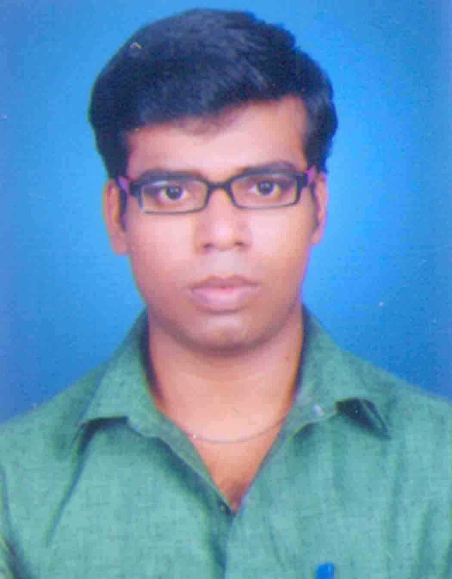
VIJAYA
E-mail: vijaya.341395@2freemail.com
C/o-Mobile: +971502360357
Objective
Seeking a position where I can explore myself in the field of education to invest my academic knowledge and practical skills in the working field and to utilize my skills and abilities to the growth of organization
Education | School/College | Year pass | Grade
M.Sc Computer Science, | Bishop Heber College (Autonomous) Trichy-620017. | April, 2016 | 7.35
B.Sc Computer Science, | Bishop Heber College (Autonomous) Trichy-620017. | April, 2014 | 6.83
H. S. School Education, | Govt.Syed Murthuza H.S.School, Trichy-6200 008. | March,2011 | 62
SSLC Education, | SRI V. V .H.S Thirupparaithurai-63115 | March,2007 | 73

Technical Expertise
Typewriting : English- Junior (first class),Senior Tamil- Junior (first class in with distinction)
Course : Certificat in Desk Top Publishing (first class-Distinction) IECD
Certificate : Offset Printing (Government of Tamilnadu Department of employment and Training,Chennai-600 032)
Programming Languages : Java, Android
Operating Systems : Windows XP, Windows 7

Tools : Adobe Photoshop, CorelDRAW, PageMaker, Excel,word, Sql,

Strengths
· Typing speed 50 wpm, Design well
· Sincere, Good Leadership, pastive think.

Co-Curricular Activities
· NSS volunteer ("Healthy youth for Wealthy India") special camp in police colony,
Navalpattu.
· I got some certificates in college level.
· I got some certificates in School level.
· I won 2nd class in 10th std Tamil (T.T.K)
Project work:
· Cut Detection in Wireless Sensor Networks used in C#.NET(UG)
· A Mobile Phone Based Medicine In-take Reminder and Monitor used in Android (PG)
Coding Language : Java 1.7 Tool Kit : Android 4.2.2
This project is used to provide guidance and support to memory-loss patients to correctly take their medications. The application helps the user suffering from memory-loss by creating alerts that tell the user when and what medication is to be taken.
Experience and part time job
. Printing press 4 years and
. 1 year in hotel sangam
. DTP designer (flex design, Books, Bussinesscards, magazine all types)
. Printinh Machine Opeator Ryobi , Binding. Billbook, pad.
Personal Profile
Relegion : Hindu
Date of Birth : 28 .02.1991
Gender : Male
Language Known : Tamil, English
Language Learn : Hindi (prathamic,madhyama), Sanskrit

Declaration
I hereby declare that the all information furnished above is correct up to my knowledge.

