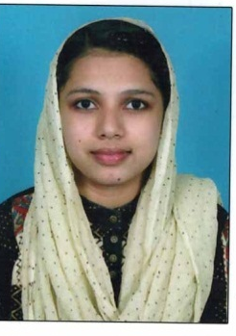
HAMDA
HAMDA.341435@2freemail.com

CAREER OBJECTIVE:

To take up a challenging job in a reputed organization where I can utilize my professional to the maximum, and achieve goals keeping in mind the aesthetics of professionalism. A job that allow me for greater achievements and which would effectively apply my professional skills and administrative experience in leadership, business and inter personal relations.

ACADEMIC QUALIFICATIONS:

- AMIE (The Institution of Engineers, India) in Computer science and Engineering completed with aggregate of 75% in 2014.
- Diploma in Computer Engineering with aggregate of 75% of marks from Kerala Govt Poly technic college in 2007-2010
- PLUS TWO(Board of Higher Secondary Examination, Kerala) with 70% marks in 2005-2007
- SSLC(Board of public examination, Kerala) with 86% marks in 2004 to 2005.

TECHNICAL QUALIFICATIONS:

- Completed internship in advanced .Net Technologies from Kelton (Kerala Govt.)In September 2014 to February 2015.
- Completed internship in Node.js,Express.js,MongoDB,Angular.js from Antso Technologies, Calicut in November 2015 to May 2016

ACADEMIC PROJECTS

- IVR Equipped college information system
Language of Implementation: Java
Data base : SQL Server
- Remote file accessing using SMS
Language of Implementation: C#.Net
Data base : SQL Server
PROGRAMMING SKILLS:

- Programming Languages :C,C++,Node.JS
- Database :SQL,MySQL,MongoDB
- Designing skills :HTML,CSS,Javascript,Jquery, Bootstrap,Angular Material

ATTRIBUTES:

- Smart, hardworking can adapt to any situation, have capacity to grasp new matters with ease.
- Able to work on own initiative and as a part of a team.
- Currently working as a software developer in Antso Technologies,Kozhikode,Kerala,India.

PERSONAL INFORMATION:
Nationality : Indian
Date of Birth : 05-09-1989
Languages : English,Hindi,Malayalam
Hobby : Designing and developing websites

I declare that the above particulars filled are correct and true to the best of my knowledge and believe.

