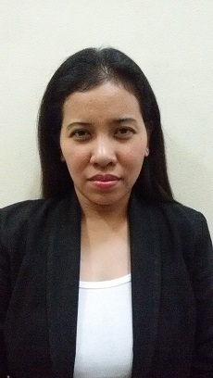Rachel
PERSONAL DATA

Gender: Female
Date of Birth: September 17, 1984
Status: Married
Nationality: Filipino
Religion: Catholic
Language Spoken: Filipino & English
Personality: An enthusiast with confidence, friendly and easy to deal with, punctual, resourceful, competitive and innovative

EDUCATIONAL BACKGROUND

SECONDARY:
Pandan School Of Arts And Trades
Pandan, Catanduanes,Philippines

ELEMENTARY:
Moonwalk Elementary School
Las Pinas City,Philippines

SKILLS
- Excellent interpersonal and analytical skills
- Organizational skills and customer service orientation
- Adaptability and ability to work under pressure
- Strong communication skills
- Effective problem solving and negotiation skills
- Ability to lead, oversee and supervise the activities of others
- Strong multitasking skills

I hereby certify that the above information is true and correct to the best of my knowledge and belief.

__________________________
Rachel J. Adviento

Rachel.341503@2freemail.com

CAREER OBJECTIVE:
To be able to join an organization that will serve as a venue for me to maximize my capabilities, as well as my potentials as a professional and as an individual with a strong sense of result-disjointedness and commitment

EMPLOYMENT HISTORY:
Oct 2016 Office Clerk
ARCHARD MIDDLE EAST
>Responsible for answering the telephone,filling data processing,faxing.

May 2006 - Telephone Operator
Sucasa massage therapy

Duties and Responsibilities:
- Responsible for answering the telephone , transferring calls, taking accurate messages, greeting customers
- Notifying staff members of any customer cancellations or the arrival of any unscheduled visitors.

January 2005 (6months) - Sales lady,
Sta. Lucia Grand East Mall

Duties and Responsibilities:
- Work with customers with the most cheerful and pleasant disposition
- Give answers to customers questions or concerns related to the product
- Communicate and assist customers in any way possible and as the customers may require
- Deal wit customers complaints professionally and with restraint
- Close as many deals and transactions as possible
- Report sales accurately

