- Ability to work independently with maximum supervision


Contact HR Consultant for CV No: 2049024
E-mail: response@gulfjobseekers.com
Website: http://www.gulfjobseeker.com/employer/cvdatabasepaid.php

Career Objective___________________________________________________________________________________
To be a part of the organization and to be equipped to meet the challenges of the company's growth. In order to develop my skills and to learn new tasks according to the job requirements.

Summary of Qualifications______________________________________________________________________
- Proficient in oral and written communication and interpersonal skills
- Knowledge of kitchen and food preparation standards
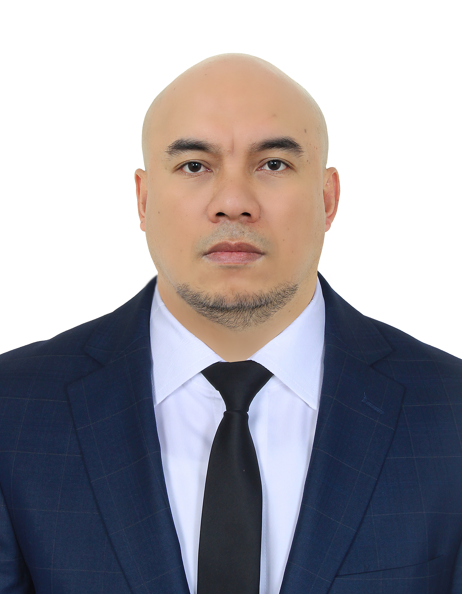

Personal Details___________________________________________________________________________________
- Fast learner, well organized, and able to do multitasking
- High degree of initiative and responsibility
- Flexible to work under pressure
- Eager to exert time and effort on task assigned
- Hardworking, trustworthy, and enthusiastic

Birthday : November 28, 1976
Gender : Male
Civil Status : Single
Height : 5’ 5”
Language : English, Tagalog, Cebuano
Visa Status : Residence Visa

Educational Attainment__________________________________________________________________________
College Bachelor of Science in Marine Transportation
(1996-2000)
University of Visayas
- Supervise and check every dish sent from the section to ensure business standards are maintained
Cebu, Philippines

Work Experience__________________________________________________________________________________
Chef de Partie
Al TAYER GROUP OF COMPANIES (OCEAN BASKET)
Airport Terminal 3, Dubai, UAE
November 2011 up to present
Duties & Responsibilities:
- Manage service during busy periods ensuring all set standards and quality procedures are adhered to
- Manage staff training with the Sous Chef and maintain an active training plan/program for each team member, make sure all practices that are trained and followed
- Ensure correct handling and usage of all equipment
- Responsible for refrigeration cleaning, stock rotation, date coding and section deep cleaning
- In the absence of a senior chef, ensure the daily kitchen records and labelling standards are being maintained at all times
- Any other duties as requested by the management
- Set up stations and collect all necessary supplies to prepare menu for service

Cook
BIN HENDI ENTERPRISES L.L.C. (JAPENGO CAFé)
Dubai, UAE
April 2007 to September 2011
Duties & Responsibilities:

- Weigh and measure ingredients for cooking
- Prepare a variety of foods including meat, seafood, poultry, vegetable and cold food items
- Prepare sauces and garnishes for allocated station
- Cover, date and correctly store all food items as per safe food-handling procedures
- Serve food in keeping with the standards of establishment
- Ensure the correct temperature of food to make it attractive and tasty
- Maintain an organized and sanitized work area at all times
- Make sure all storage areas are tidy and all products are stored appropriately
- Constantly use safe and hygienic food handling practices
- Operate and maintain all kinds of kitchen appliances
- Perform record keeping and reports generation duties
- Order and take delivery of food and supplies
- Prepare ingredients such as meats and vegetables that need to be used for food preparation purpose

Assistant Cook
Kanchiko japanese restaurant
Cebu, Philippines
April 2000 to October 2000
Duties & Responsibilities:
- Assist in preparation of cooking menu items
- Check all items to ensure adequacy and quality
- Test new recipes for quality and taste
- Maintain records of prepared food and manage inventory

Butcher cum Kitchen Crew
Europa delicatessen & Butcher shop
Cebu, Philippines
February 1995 to March 2000
Duties & Responsibilities:
- Cut or prepare meats to specification or customer’s orders
- Store meats in refrigerators or freezers at the required temperature
- Keep inventory of meat sales and order meat supplies
- Clean equipment and work areas to maintain health and sanitation standards

Manila Hotel, Manila, Philippines
Training and Seminars___________________________________________________________________________
- Boecker Hygiene Training
Al Aweer, Dubai, U.A.E.

- MEDCO (Australian Meat Seminar & Training)
Diplomat Hotel, Cebu City, Philippines

- Henri Marie France (Wine Tasting & Seminar)

