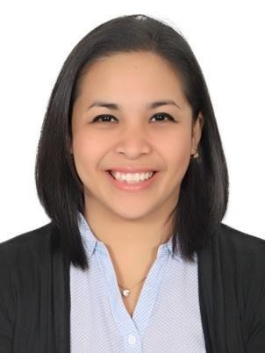
MARIEL

C/o-CONTACT NO: +971503718643

mariel.341522@2freemail.com

Career Objective:

To have an opportunity to work on your company for my career advancement and to have a contribution for the development and growth of your company.

Working Experience

Nanny for Murschel Family from February 20, 2016- Present

- Prepares meals

- Keeps the house neat and tidy

- Laundry and ironing

- Grooming of the kids, prepares them for school

- Recreation with the kids

Child care at Kalimat Center from March 13, 2015 – January 21, 2016

- Prepares and gives milk/food

- Diaper change

- Recreation

- Keeps play area neat and tidy

Caregiver/private nurse of Ibrahim Thani Saeed Alsuwaidi, Sharjah, UAE from February 3, 2013 to February 3, 2015

- Monitors BP and Blood sugar

- Gives medications and insulin injections

- Prepares and gives food

- Accompanying to the bathroom ( assist in giving baths and personal care)

- Accompanying to the hospital for dialysis 3x a week

Part-Time Sales Associate at Fashion Hub Ultimart, San Pablo City from December 10-24, 2010

- Assist the customers with their needs

- Arrange items according to their brands and labels

- Keeps the store clean

Management Trainee at Video City San Pablo City from September 2006-March 2007

- Assist with the daily responsibilities and duties

- Keeps the store organized and neat

- Checks petty cash

- Assist the customers with their inquiries

Personal Background:

Birth Date | : | November 30, 1985
Birth Place | : | San Pablo City, Philippines
AGE | : | 31
Height | : | 5’3
Status | : | Single
Nationality | : | Filipino
Religion | : | Roman Catholic

Educational Background:

➢ Tertiary | : | Laguna College​, ​Bachelor of Science in ​nursing​from ​2002-2006
➢ Secondary | : | Laguna College from 1998-2002
➢ Primary | : | Grace and Truth Elementary School 1992-1998

Skills​:

- Computer and Microsoft Literate
- Self-motivated, initiative and responsible in nature
- Excellent command in English spoken or written
- Ready to learn and adapt with new environment

Seminars Attended :

- CPR and First Aid Training

Philippine National Red Cross San Pablo City Chapter Laguna College, 2003

- Disaster Management Training

Philippine National Red Cross San Pablo City Chapter June 4-8, 2007

- Basic Leadership Training

Philippine National Red Cross San Pablo City Chapter June 25-27, 2007

I HEREBY CERTIFY that the above information is true and correct to the best of my knowledge and belief.

Mariel

