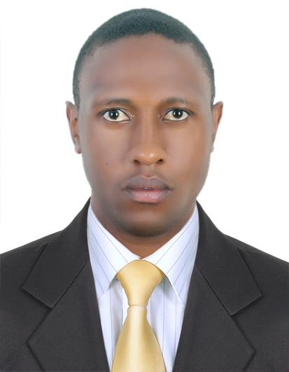
CURRICULUM VITAE

Name :Samuel
Email : Samuel.341525@2freemail.com
C/o-Phone : +971 502360357
.
Address: Satwa Dubai.

Visa : visit

Objective:
To work in an organization, in which I can prove my information technology skills and customer service to become a perfect link between the company and its customers, thereby proving effective advancements in information systems.
Summary of Qualifications;
Experienced and knowledgeable Information Technology Professional seeking to contribute training and acquired skills Work well independently, or in a group setting providing all facets of computer support such as troubleshooting, installations, and maintenance. Skilled in providing Customer and End-User Help Desk Support. Easily identify and resolve technical issues and concerns.
Work Experience:
2015:
I.T support at NEO I.T SOLUTIONSL.L.C at bank street Bur Dubai ,Dubai U.A.E
Duties:
- Provide IT support to all company employee
- Prepare new user desktops or laptops for use
- Diagnose user problems
- Monitor and manage anti-virus & Windows updates
- Maintain Active Directory and Exchange accounts
- Monitor internal networks at datacenters and remote sites
- Attend to any system failures on site and out of office hours if necessary
- Onsite operating software installation and training, for example , Opera ,POS, QuickBooks, Tally ERP , Micros
2012-2014
Senior Technician at ITchase.com.Bur Dubai, Computer Plaza. Dubai

Duties:
- Providing support in the service center
- Assembling all types of pc’s and upgrading old ones
- Chip level repairs in all kinds of laptops and motherboards
- Networking(routers configuration and installations)
- All hardware and software troubleshooting
- Data recovery
- Service center team manager.

Safari park Hotel (Nairobi) Kenya - July 2009 to August 2012

Information Technology Technician

- Provided computer help desk support via telephone communications with end-users.
- Provided computer help desk support and technical training on hardware/software to end users.
- Perform the tasks of installing, maintaining and configuring software and hardware systems
- Responsible for handling database archiving and system back-up processes to ensure data recoverability
- Handle the tasks of testing server and network systems to verify functionality and performance
- Perform responsibilities of providing technical support to telephones, networks, servers, and other computing platforms

Bright Technologies - (Nairobi) Kenya-Jan 2005 to Jun 2009

SalesRepresentative :
- Maintained good relations with existing customers to promote new and upgraded products.
- Offered technical support by solving faults and problems.
- Achieved sales target set by my managers and also contributed in the achievement of team targets.
- Offers support to customers, wherever and whenever possible.
- Advised and guided the customers about the software features and their usage in different contexts.
- Provided technical advice to customers on all installation and usage aspects of computer systems and networks both pre as well as post sales.
- Developed impressive sales plan through effective sales methodology.
- Assisted with the company helpline and serve as customer representatives to customers having technical difficulties.
Education
Robben Institute Of Professional Studies-(Nairobi) Kenya

Diploma in Information Technology and Electronics :
- Electronics components and application
- Engineering graphics
- Electronics equipment maintenances
- Hardware and maintenances
- Mobile communication and software
- Fault diagnosis and troubleshooting
- Circuit /motherboard installation and repair

Robben Institute Of professional Studies(Nairobi) Kenya - Jan 2001 to Mar 2001

Diploma in Sales and Marketing:

- Principle of management
- Principle of accounts
- Business Communication and office management
- Principle of purchasing

Lari High School-(Nairobi) Kenya - Mar 1997 to Nov 2000

Kenya Certificate of Secondary Education(O-levels).
Hobbies
Socializing, watching movies and cycling.
Personal Details

Nationality : Kenyan
Date of Birth : 10th Dec 1981
Languages : English, Swahili.

