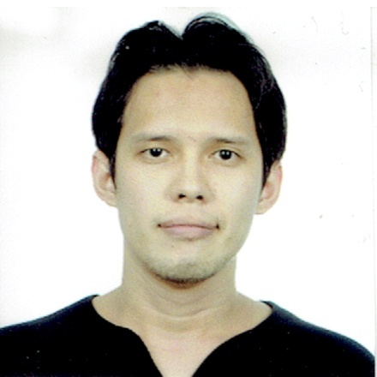
Patrick
C/o- +971502360357
Patrick.341593@2freemail.com

PERSONAL INFORMATION

Birthday : October 10, 1986
Birthplace : Cebu City
Age : 30
Status : Single
Height : 5’6”
Weight : 65 kg
Nationality : Filipino

EDUCATIONAL BACKGROUND

Tertiary Notre Dame of Dadiangas University
Marist Avenue, General Santos City
Bachelor of Science in Computer Science
2012

Secondary Notre Dame of Dadiangas College - Integrated Basic
Education Department
San Pablo St., Lagao, General Santos City
2003

Primary Notre Dame of Dadiangas College - Elementary Training Department
Marist Avenue, General Santos City
1999

COMPUTER SKILLS

- Assembling Desktop Computer
- Reformatting
- Troubleshooting
- Networking
- Proficient in MS Office
- Programming using:
- Visual basic .Net
- C Language

AFFILIATIONS

Computer Age Society (CAS)
Notre Dame of Dadiangas University
Marist Avenue, General Santos City
Member
2003 - 2008

Philippine Society of Information Technology Students (PSITS)
Notre Dame of Dadiangas University
Marist Avenue, General Santos City
Member
2010 - 2012

CERTIFICATE
Certificate of Eligibility
Career Service Professional Examination
Aril 6, 2014

WORK EXPERIENCE
JCC Puericulture Center
On-the-Job Training
Programmer
Administrative and Accounting Department
City Hall Compound, General Santos City

Allphones
2IC – Admin
March 16, 2014 – January 24, 2016
3rd Level Centrio Mall, Cagayan de Oro City

I certify that the above information are true and correct to the best of my knowledge and abilities.

