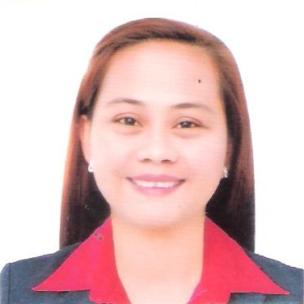
BARBOLINO
C/o- Mobile No.# +971503718643 Email add.: barbolino.341602@2freemail.com

OBJECTIVE
- I am seeking a competitive and challenging environment where I can serve your organization and establish an enjoyable career for myself.
QUALIFICATIONS AND STRENGTHS
Able to give detailed and accurate care to clients
Comprehensive knowledge of both child and elderly caregiving
Friendly, cheerful, dependable personality
Thorough understanding of health and safety practices
Hands-on experience in housekeeping and preparing nutritious meals
SKILLS
Proven ability to communicate highly technical information in an accurate and tomer-friendly way
Excellent verbal and written communication skills
AFFILATION
NC II CAREGIVING Nightingale Caregiver & Advanced Technology School Inc. Jan. 14, 2016

WORK EXPERIENCE
Alisto Travel Agency Travel Agent 2011-2013 Pasay City Branch
Smart Telecommunication Smart Brodband Agent 2011 Makati City
PinoySisig Cashier 2010-2011 Alabang Branch

EDUCATIONAL BACKGROUND
VOCATIONAL COURSE 6 Months CAREGIVING COURSE
University of Batangas
May – December 2015
SECONDARY Jose J. LeidoJr.National High School
2000-2003
PRIMARY Camilmil Central School
1993-2000
PERSONAL REFERENCE

Sex : Female
Place of Birth : GulodLabac, Batangas City
Date of Birth : October 6,1985
Age : 31
Nationality : Filipino
Civil Status : Single
Religion : Roman Catholic
Dialect Spoken/ written : English/ Tagalog

CHARACTER REFERENCE
*upon request

I hereby certify that the above information is true and correct to the best of my knowledge and belief.

TRAININGS AND SEMINAR ATTENDED
TOTAL CARE AND MANAGEMENTY OF STROKE PATIENT
Nightingale Caregiver & Advanced Technology School Inc. Jan. 22, 2016

SAGIP BUHAY TAHANAN( Home for Ederly,Handicapped,Abused& Abandoned
Nuestra Senora De,Guia Subd.Pobl.2 Bauan, Batangas December 20 - 29, 2015

CLINICAL EXPOSURE TRAINING
St. Patrick’s HOSPITAL Medical Center November 30 - Dec 4, 2015

CLINICAL EXPOSURE TRAINING
BatangasMedical Center November 23 - 28, 2015

STANDARD FIRST AID TRAINING
Philippine Red Cross,Batangas City Chapter November 21,2015
BLS-CPR TRAINING FOR HEALTHCARE PROVIDERS
Philippine Red Cross,Batangas City Chapter November 17, 2015

Understanding Middle East Respiratory Syndrome Coronavirus
[MERS-CoV] A Talk with Expert
Batangas Main Campus

