Resume 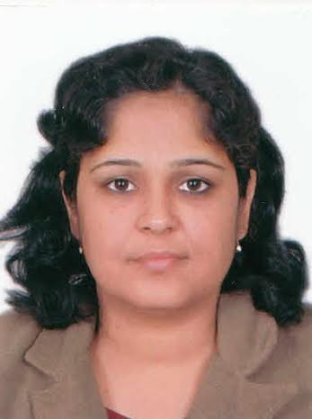

Neeraj
Neeraj.341608@2freemail.com

Position Sought : Art and Craft teacher

OBJECTIVE
seeking a teaching position where I can enhance the Art and provide an extraordinary environment for students so they are able to recognize their full creative talents.

STATEMENT

I am a quick learner with strong interpersonal skills, with 9 years of experience in the Animation and Illustration industry and 3.5 years teaching experience in school. I believe that I have the qualifications and the enthusiasm to work in a challenging environment.

STRENGTH

Punctuality, Job Satisfaction, Industrious & Honesty.

EDUCATIONAL QUALIFICATION

Bachelor of Fine Art from Jamia Millia Islamia University. (1998-2001)
1 year diploma course in 2D Animation from Escotoonz (ESCORTS) (2001-2002)

COMPUTER KNOWLEDGE
Adobe Photoshop, Microsoft Word

PROFESSIONAL SUMMARY
School : Delhi Public School
Greater Noida
Industry: Education
Duration : From April 2013 to Present
Designation : Primary Teacher (Art)

Company : B. Jain Publishers (P) Ltd.
Street no 10, Paharganj, New delhi- 55
Industry : Publishing
Duration : From June 2011 to Feb 2013
Designation : Freelance Illustrator

Company : Xact Times Group
Modi Complex, Ashok Vihar, Phase-2, New Delhi-52
Industry : Publishing
Duration : From July2008 to May 2011
Designation : Illustrator

Company : ESCOTOONZ
Mathura road, Faridabad
Industry : Animation
Duration : From 2002 - 2005
Designation : Clean up & IB artist

PERSONAL DETAILS

Name: Neeraj
Date of Birth : February 16, 1980
Languages Known : English, Hindi, Bengali,
Marital Status : Married
Experience: 9 Years

DECLARATION

I hereby declare that the above written particulars are true to best of my knowledge.

