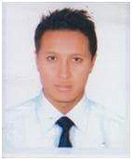
SUMAN.341625@2freemail.com
NAME: | Suman
APPLICATION FOR THE POST OF : |  |  | Chef de partie

CAREER OBJECTIVE: As a dynamic person in hospitality. To seek an opportunity in the field of business that would best fit my knowledge and develop further my talent and skill for continuous career development.

WORK RELATED SKILLS

- Communication : Talking to others to convey information effectively . Giving full attention to what other people are saying , talking time to understand the points being made, asking questions as appropriate, and not interrupting at inappropriate time .
- Quality control : conducting tests and inspections of products, services or processes ìto evaluate quality or performance.
- Active learning: understanding the implications of New information for both current and future problems solving and decision making.
- Time management : managing one's own time and the time of others.
- Mathematics : using mathematics to solve problems.

CHRONOLOGICAL ORDER OF EXPEREINCE
COMPANY | DESIGNATION | TIME PERIOD | LOCATION
One life kitchen and cafe | Chef de partie | At present | Dubai
The media lounge (TML) | demi chef de partie | 1 year | Dubai
Mark inn hotel | Commis1 | 2 years | Dubai
Abela catering company | Asst cook | 1 year | Dubai

PROFESSIONAL EXPERIENCE
EMPLOYER NAME : one life kitchen and cafe
Period: at present
Contact Number :
Can Arrange Experience certificate
( YES/NO):yes
DUTIES & RESPONSIBILITIES: ■ preparing, cooking and presenting dishes with own specialty.
■Helping the sous chef to develop new dishes and many.
■Maintain high standards of food hygiene and follow the rules of health and safety .
■Monitoring portions and waste control to maintain profit margins .

TOOLS/EQUIPMENT /MACHINERY AT USED AT WORK :
■Baking and roasting
Baking mats, muffin pans, chestnut roaster, baking sheets.
■Basting and marinating.
Basher, basting brush, oil sprayer
■Cookware.
Mixing bowls, sauce pan, stock pot.
■ For Egg
Egg timer ,egg cups,egg spoons, omlete pan.
■Fork an picks.
Fork, poultry lifters, salad tongs , seafood fork, snail forks ,tongs
■Grilling and smoking
Grilling basket , skewers,
■Blenders.
Counterto blender, hand blender, vitamix
■ Cooking from the outlet .
Toaster oven,induction cookpot, deep fryer,rotisserie oven

EMPLOYER NAME : The media lounge (TML)
Position :demi chef de partie
Website:
Period: 1 year
Can Arrange Experience certificate
( YES/NO): yes
DUTIES & RESPONSIBILITIES: ■ Maintaining high standard of hygiene.
■ preparing the ingredients for a more senior Chef.
■Measuring fish ingredients and portion sizes accurately.
■Dealing with deliveries and stock rotation.

TOOLS/EQUIPMENT /MACHINERY AT USED AT WORK :
■ Knife.
Nakiri knife, fillet knife, cleavers knife ,watermelon kni
■ Hand protection.
Oven mitts, pot holders, oven push/pull, oven rack guard.
■Measuring .
Kitchen scale. Measuring cup,measuring spoons, timer
EMPLOYER NAME : Mark inn hotel
Position : commis 1
Website:
Period: 2 years
Reference Person: none
Contact Number :none
Can Arrange Experience certificate
( YES/NO): yes

DUTIES & RESPONSIBILITIES: ■ Assist the chef de partie in the production.
■ Attends meetings and training sessions organised by hotel management For the position.
■ Learning about food safety techniques.
■ Preparing foods for more en place , which involves chopping vegetables, stocking stations, organizing ingredient and partly cooking some foods .

TOOLS/EQUIPMENT /MACHINERY AT USED AT WORK :
■Meat prepping,
Meat grinder, meat slicer , patty press.
■ Measuring and spoons.
Caviar spoons , I’ve cream spade, ladle, mixing spoons , serving spoon,slotted spoons, spatula.
■Starining
Chinois, lemon juicer, pot strainer

EDUCATION
COURSE | INSTITUTE | DURATION | YEAR of passing
School leaving certificate (SLC) | Janak siddhikali secondary school | 1 years | 2008
Cooking class | Kamana cooking school. | 6 months | 2011

TRAININGS & CERTIFICATIONS & ACHIVEMENTS
■ I have got 6 months cooking training in kamana hotel manageme institute from katmandu.
■I have successfully complet food hygiene training by abela & co.l.l.c
PERSONAL DETAILS
PERSONAL PROFILS:
Date of Birth | : |  |  |  | 02/10/1989
Gender | : |  |  |  | Male
Religion | : |  |  |  | Hindu
Nationality | : |  |  |  | Nepal
Languages Known | : |  |  |  | English, nepali,hindi

ENGLISH LANGAUGE SKILLS
ACCEPTABLE/POOR | GOOD | VERY GOOD | EXCELLENT | IELTS SCORE  ( IF APPLICABLE)
 | Good

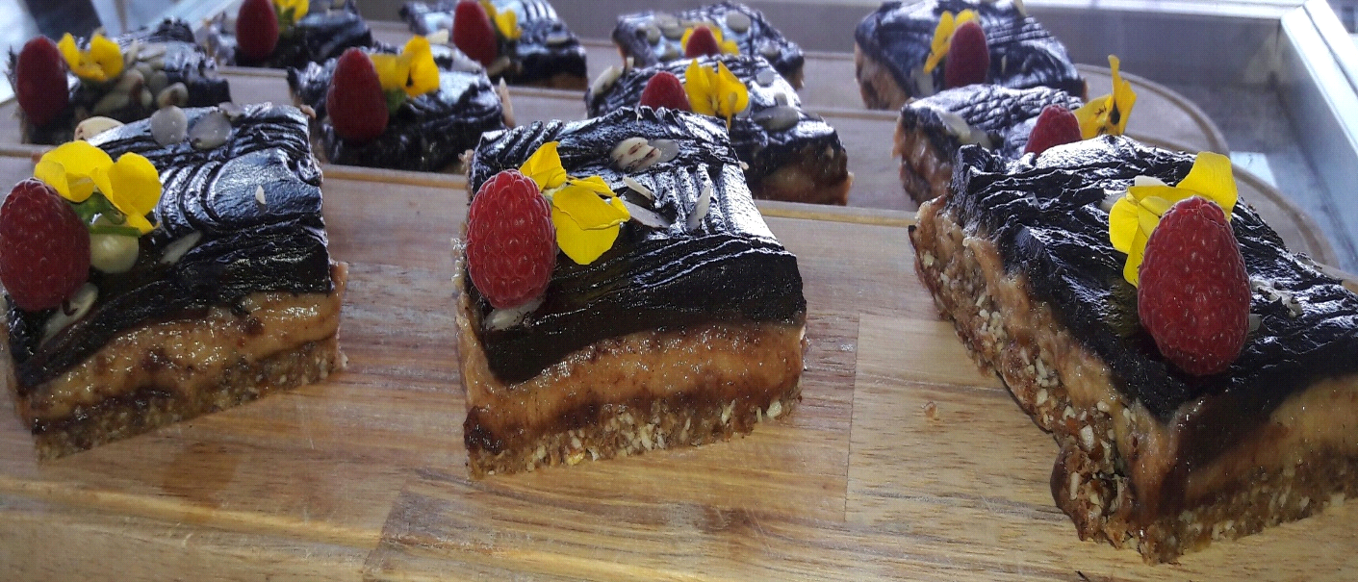
Sweet of the day, chocolate caramel slice.

I hereby certify that the above information is true to the best of my knowledge and belief.

